NORTH CENTRAL TEXAS COLLEGE

COURSE SYLLABUS

PLEASE READ THE STATEMENT FROM NCTC ADMINISTRATION ABOUT COVID-19 APPENDED AT THE END OF THIS SYLLABUS.

Course Title: | Principles of Financial Accounting
Course Prefix & Number: |  | ACCT2301 | Section Numbers: | 0610 | Semester/Year: | SU2021
Semester Credit Hours: |  | 3 | Lecture Hours: | 48 | Lab Hours: | 0
Course Description (NCTC Catalog): Fundamentals of financial accounting concepts and interpretation of accounting data; analysis of financial statements; income and cash flow analysis; nature of assets, liabilities, and equities; and understanding and use of the accounting process. The course will include computer applications.
Course Prerequisite(s): MATH1314 and BCIS 1305 or equivalent are recommended. MATH1324 (Mathematics for Business & Social Sciences) is co-recommended.
Instructor’s Note: Most mathematical operations required for this class are no more complex than addition, subtraction, multiplication, and division. However, competencies in spreadsheet programs (MS Excel, Quattro Pro, Google Sheets) will be helpful.
Required or Recommended Course Materials:

TEXT: Financial Accounting: Information for Decisions, 10e: Wild.
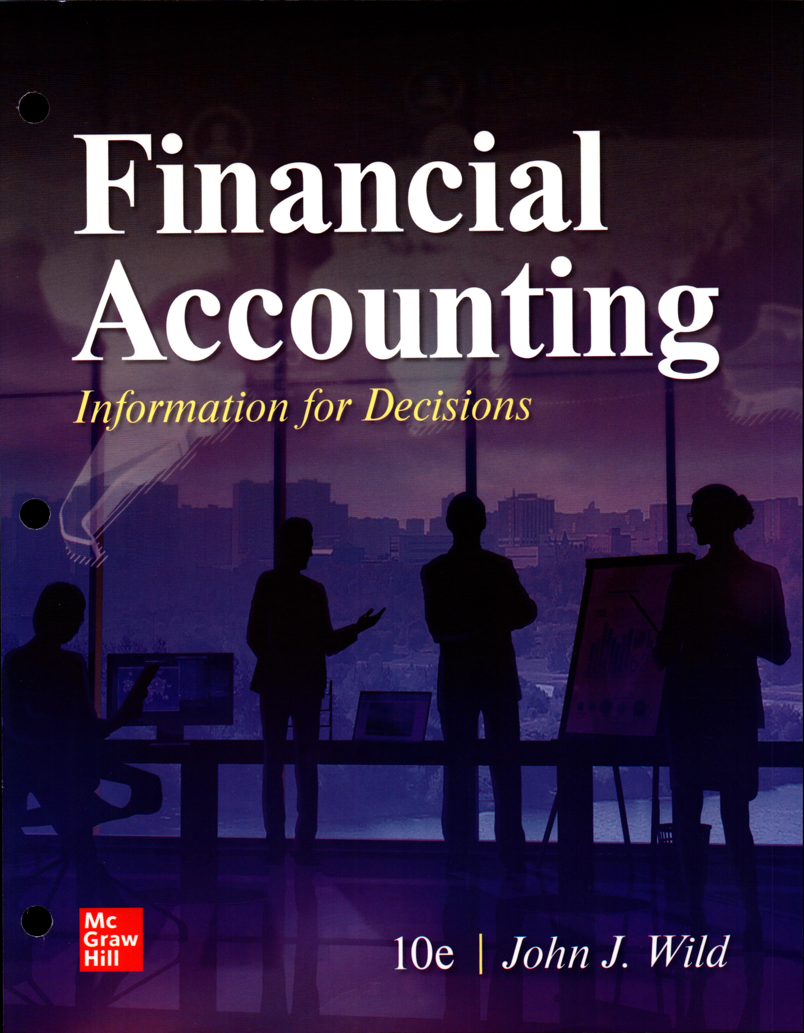
Be sure you purchase access to McGraw-Hill CONNECT. All course assignments and supplementary materials are delivered through CONNECT.

Technology Requirements: Students must have access to the Internet and have the digital hardware and software required to access the course and complete assignments via Canvas and McGraw-Hill CONNECT. If and as required, students may need to use productivity software such as Microsoft Office or Google docs (free).

INSTRUCTOR INFORMATION
Name of Instructor: | Richard W. Walker
Class Meeting Times | 11 a.m.-12:50 p.m., DNX room 114.
Campus/Office Location: | I am an adjunct instructor. I do not have an office.
Telephone Number: | 214-507-4610—TEXT PREFERRED.
E-mail Address: | rwalker@nctc.edu

Instructor’s Note: the preferred way to contact me is by text at 214-507-4610. Tell me who you are and in which section you’re enrolled, then ask your question. You may also call me. If I cannot answer right away, I should be able to return your call that day unless I’m traveling. Please keep texts and voicemails brief. If a longer message is needed and especially if you need to include a screenshot and a narrative about the problem you’ve encountered, I encourage you to email me, then text me so I will know to look for it at the first possible opportunity.

OFFICE HOURS
Monday | Tuesday | Wednesday | Thursday | Friday
I am usually available from 10 am-11 am prior to class on MTRF.
I am available by appointment or by text/cell/email at all other times.

I have a full-time job but work from home. Therefore, my schedule is flexible. So, I should be able to accommodate your requests for information and/or assistance or to answer any questions you may have. To repeat, texting me is best but feel free to call. For longer messages, please email but then text me to alert me that you’ve sent the email.

ACCT2301—PRINCIPLES OF FINANCIAL ACCOUNTING:
This course is an introduction to the fundamental concepts of financial accounting as prescribed by U.S. generally accepted accounting principles (GAAP) and applied to transactions and events that affect business organizations. Students will examine the procedures and systems to accumulate, analyze, measure, and record financial transactions. Students will use recorded financial information to prepare a balance sheet, income statement, statement of cash flows, and statement of shareholders' equity to communicate the business entity's results of operations and financial position to users of financial information who are external to the company. Students will study the nature of assets, liabilities, and owners' equity while learning to use reported financial information for purposes of making decisions about the company. Students will be exposed to the similarities and differences between GAAP and International Financial Reporting Standards (IFRS).

Accounting is the grammar of commerce. The financial nomenclature and general business taxonomy you learn in this class is vital to your success in any business endeavor—especially finance, marketing, management—in addition to accounting.

STUDENT LEARNING OUTCOMES (From Academic Course Guide Manual/Workforce Education Course Manual/NCTC Catalog).

ALL ASSIGNMENTS WILL BE BASED ON STUDENT LEARNING OUTCOMES.

At the successful completion of this course the student will be able to:
1. | Use basic accounting terminology and understand and apply the assumptions, principles, and constraints of the accounting environment.
2. | Identify the differences between cash and accrual accounting.
3. | Analyze and record business transactions in accordance with Generally Accepted Accounting Principles in the U.S. (GAAP).
4. | Prepare adjusting entries and close the general ledger to complete the accounting cycle.
5. | Prepare financial statements in accordance with GAAP, including but not limited to the Income Statement, Balance Sheet, Statement of Cash Flows, and the Statement of Stockholders’ Equity.
6. | Analyze and interpret financial statements using financial analysis techniques.
7. | Describe the conceptual differences between International Financial Reporting Standards (IFRS) and GAAP.

GRADING CRITERIA
# of Graded Course Elements | Graded Course Elements (based on Student Learning Outcomes) | Percentage or Point Values
See your Course Calendar | Chapter Homework (HW) | 35%
 | Exams—four unit exams | 60%
 | Learning Outcome Assessments | 5%

Grading Criteria
(in accordance with NCTC’s standard policy)

A | 90-100
B | 80-89
C | 70-79
D | 60-69
F | <60

ATTENDANCE POLICY
Regular and punctual attendance is expected of all students in all classes for which they have registered. Consult your Syllabus and Course Calendar for all due dates and other responsibilities.
All absences are considered to be unauthorized unless the student is absent due to illness or emergencies as determined by the instructor. It is the student’s responsibility to provide documentation as to the emergency for approval and judgement by the faculty member.
Approved college-sponsored activities are the only absences for which a student should not be held liable and only when provided by a college official ahead of the absence. Valid reasons for absence, however, do not relieve the student of the responsibility for making up required work.
Students will not be allowed to make up an examination missed due to absence unless they have reasons acceptable to the instructor. A student who is compelled to be absent when a test is given should petition the instructor, in advance if possible, for permission to postpone the exam. Student will be dropped from a class by the Registrar upon recommendation of the instructor who feels the student has been justifiably absent or tardy a sufficient number of times to preclude meeting the course’s objectives. Persistent, unjustified absences from classes or laboratories will be considered sufficient cause for College officials to drop a student from the rolls of the College. From Board Policy FC (LOCAL).
Instructor’s Note: Study after study over many years confirms that the number-one predictor of student success—far more than intelligence—is attendance.

“80% of success is showing up.”—
Broadway composer, Richard Rogers.

Other notables, such as comedian and filmmaker Woody Allen and management guru Tom Peters have added that “the remaining 20% is following up.”

Attendance will be taken for each class and also will be recorded based on your completion of Homework (HW) assignments and Exams. There is an automatic five-point penalty for approved late submission of homework assignments and an automatic 10-point penalty for late submission of exams.

Grade Appeals and Incomplete Grades: Students can read more about the college's grade appeal processes and procedures for assigning incomplete grades by visiting the Academic Catalog: https://www.nctc.edu/catalog/academic-policies/grades-reports/student-grade-appeal.html (Links to an external site.) and https://www.nctc.edu/catalog/academic-policies/grades-reports/incomplete-grades.html (Links to an external site).

Withdrawing from a Course: Students can learn more about the withdrawal policy and procedure at http://www.nctc.edu/current-students/drop-withdraw-class.html (Links to an external site.).

DISABILITY SERVICES (Office for Students with Disabilities)
The Office for Students with Disabilities (OSD) provides support services for students with disabilities, students enrolled in technical areas of study, and students who are classified as special populations (i.e. single parents).
Support services for students with disabilities might include appropriate and reasonable accommodations, or they may be in the form of personal counseling, academic counseling, career counseling, etc. Furthermore, OSD Counselors work with students to encourage self-advocacy and promote empowerment. The Counselors also provide resource information, disability-related information, and adaptive technology for students who qualify.
If you feel you have needs for services that the institution provides, please reach out to either Wayne Smith (940) 498-6207 or Yvonne Sandman (940) 668-4321. Alternative students may stop by Room 170 in Corinth or Room 110 in Gainesville.
CORE CURRICULUM FOUNDATIONAL COMPONENT AREA (For classes in the Core)

□ Communication
□ Mathematics
□ Life and Physical Science
□ Language, Philosophy & Culture
□ Creative Arts
□ American History

□ Government/Political Science
□ Social and Behavioral Sciences
□ Component Area Option

REQUIRED CORE OBJECTIVES (For classes in the Core)

□ Critical Thinking
□ Communication
□ Empirical and Quantitative

□ Teamwork
□ Personal Responsibility
□ Social Responsibility
COURSE TYPE
√ Academic General Education Course (from ACGM but not in NCTC Core)
□ Academic NCTC Core Curriculum Course
□ WECM Course

STUDENT HANDBOOK
Students are expected to follow all rules and regulations found in the student handbook and published online.

ACADEMIC DISHONESTY
Scholastic dishonesty shall include, but is not limited to cheating, plagiarism, academic falsification, intellectual property dishonesty, academic dishonesty facilitation and collusion. Faculty members may document and bring charges against a student who is engaged in or is suspected to be engaged in academic dishonesty. See Student Handbook, “Student Rights & Responsibilities: Student Conduct ([FLB(LOCAL)]”.

Consequences for academic dishonesty may include:
- First offense: written warning and fail assignment.
- Second offense: fail class, possible suspension.

Capstone Requirements for Accounting Majors:

The capstone for the Accounting Technician Certificate is a comprehensive program exam with a score of 70% or higher. The exam must be scheduled with the Department Chair upon completion of a certificate.

The capstone requirement for the AAS Degree in Accounting is ACNT 2302 Accounting Capstone. It should be taken the last semester before graduation. This course may not be substituted.

QUESTIONS, CONCERNS, or COMPLAINTS
Name of Chair/Coordinator: | Dr. Cherly Furdge
Office Location: | Corinth campus—Suite 239, Office 234
Telephone Number: | 940-498-6238
E-mail Address: | cfurdge@nctc.edu
Name of Instructional Dean: | Debbie Huffman
Office Location: | Gainesville campus—Building 2100, Office #2106
Telephone Number: | 940-668-3357
E-mail Address: | dhuffman@nctc.edu

OTHER PERTINENT INFORMATION

Coursework:

- Accounting course are extremely challenging and demanding and move at a fast pace. They require more than the usual commitment, both in time studying and solving the problems, even in a long semester. Shorter courses are even more demanding.

- During the course of this semester, please communicate through Canvas email, text, or phone (214.507.4610). Do not use email accounts other than your NCTC Canvas email account.

- All coursework is available via the Internet through NCTC’s Canvas Learning Management System. Through Canvas, many assignments are available in and completed through McGraw-Hill Connect.

- Students should login to Canvas a minimum of four times per week.

- If a student experiences a problem/s accessing course materials in Canvas or via sending/receiving Canvas email, it is the student’s responsibility to contact the e-Learning Helpdesk by submitting a ticket: https://ecampushelpdesk.nect.edu/hc/en-us, then notifying the instructor of the problem.

- Students should record a screenshot of the issue/s to help IT resolve the issue/s. Also, send the screenshot to the instructor.

- If the problem/s occur in McGraw-Hill Connect, it is the student’s responsibility to contact McGraw-Hill’s support representatives. Be sure to save the ticket number for your records, then send the screenshot of the problem/s and the ticket number to the instructor.

Homework, Exams, Other Assignments:

- The student should read the course Syllabus and Course Calendar closely for important dates, both opening and due dates. There are penalties for late submission; in some cases, it is not possible to make-up assignments.

- Learning Outcome Assessment (LOA) quizzes count toward 5% of your semester grade. Several of the LOA questions are available in Connect. Those questions also appear in your Homework Quizzes. Ask your Instructor if you need more information.

- There is no extra credit.

Other Information:

- Accounting is a subject that progresses. Beginning with the introduction in your text, mastery of succeeding topics depends on mastery of topics previously covered.

- Students are responsible for keeping track of the assignments and their grades. Assignments cannot be opened early, nor may they be extended beyond their due dates.

- If you believe any grade to be in error, contact the Instructor immediately.

- The student is responsible for his/her grade.

- The student is responsible for dropping the class and is responsible for completing the required paperwork to do so.

- The Instructor reserves the right to change course assignments, grading policies, assignment schedules, etc. at any time.

COVID-19 Specific Syllabi Statements Summer 2021

Syllabi statement regarding potential Conversion of Onsite Classes to Online/Remote Format: North Central Texas College students should be aware that in the event of a college closure due to COVID-19 or other health related crisis, onsite classes will be converted to an online/remote format. Students should plan ahead to ensure they have access to the computer equipment (either PC, MAC, or tablet), webcam, and internet connectivity to continue their classes in an online/remote format. Please read all your official North Central Texas College student emails as the transition from onsite to online/remote might require a reorganization in your personal situation. Students will be granted a 72-hour transition and grace period. Online classes will continue as scheduled without disruption. Wear a mask, stay safe, and contact your Instructor as the situation arises. These policies and procedures were updated on June 2, 2021 and are subject to change as conditions change.
Syllabi Statement Regarding Face Coverings: Per the North Central Texas College guidance on face coverings on campus, in the instructional setting, faculty and students are not required to wear face coverings, such as masks or face shields. In May, Texas Governor Gregg Abbott released an Executive Order prohibiting Government entities from mandating the use of masks. As a political subdivision of the State of Texas, NCTC will follow the Governor’s Executive Order for Government entities and effective immediately NCTC is no longer mandating the use of masks while on campus. This order does not mean that you cannot choose to wear a mask, rather it is no longer allowed to be mandated. These policies and procedures were updated on May 19, 2021 and are subject to change.
Return to Standard Attendance Protocol for Face-to-Face Meetings: We recently faced an unprecedented situation in which all of us had to be flexible and make prudent decisions in the best interest of our families, our campus, and our community. In light of this, North Central Texas College is temporarily establishing the requirement that faculty keep records of student attendance for face-to-face course meetings as well as a documented seating chart. In addition, students who are sick or need to quarantine should not attend classes. Students will not be required to provide formal documentation from a health care provider and will not be penalized for COVID-19 related absences when proper notification to campus health officials is made in accordance with the guidelines stated below.

Faculty will:

- Notify students about important course information and delivery changes through Canvas and campus email.

Students should:
- Provide notification to campus officials if they have tested positive for COVID-19 or have to quarantine so we can confirm reported absence with instructors, monitor, and assist the campus community.
- Notify instructors in advance of the absence.
- Connect with that class through Webex if the class session is being transmitted in a hybrid fashion.
- Keep up with and/or make up missed classwork or assignments.
- Submit assignments digitally through Canvas or other means as announced by your instructor.
- Work with their instructors to reschedule exams, labs, and other critical academic activities described in the course syllabus.
- Check Canvas and campus email daily to receive important announcements pertaining to the course.
During the summer 2021 semester, faculty with face-to-face meetings will establish assigned seating/workstations to facilitate roll-taking, and, if necessary, contact tracing. Additionally, we ask all members of the College community to be attentive to their health, and safeguard others, by following the CDC’s guideline to “stay home when you are sick.” You should stay home if you have symptoms. More information on what to do if you are sick is available at the CDC’s website.

Additional NCTC information is available at http://www.nctc.edu/coronavirus/index.html

