COURSE SYLLABUS

COURSE AND INSTRUCTOR INFORMATION

Course title: Art Appreciation
Course prefix, 1301 0403
Semester/Year of course: FALL 2023
Semester start and end dates:8/22/2022 -12/10/2022
Modality (Face to face):
Class meeting Room 310, MW, and 12:30-1:50 PM:
Lab meeting location, days, and times:
Semester credit hours: 3:00
Course description: A course open to all students directed toward understanding the elements and principles of art as applied to the visual arts: painting, sculpture, and architecture as well as printmaking, ceramics, metal work and weaving. 48 lecture hours. Meets NCTC Core Curriculum Requirement.
Course prerequisites:

Course Content College-level courses may include controversial, sensitive, and/or adult material. Students are
expected to have the readiness for college-level rigor and content.

Required course materials: Living with Art 12th Edition, Mark Getlein, ed.
Name of instructor: George Moseley
Office location:
Telephone number: 940 498-6204
E-mail address: gmoseley@nctc.edu
Office hours for students: TBD

SYLLABUS CHANGE DISCLAIMER

The faculty member reserves the right to make changes to this published syllabus if it is in the best interest of the educational development of this class. Any such changes will be announced as soon as possible in person and/or writing.

SUMMARY OF COURSE ASSIGNMENTS

List of graded assignments: Your grade for this course will be determined by exams, an Art Review or Compare & contrast essay, hands-on projects, and discussion short essays.

The five grades (five exams and an art project which consists of: an Art Review and a Compare & Contrast essay) are each worth 20 %. Class participation is a must and can help with grades that border between C/B, B/A, etc.
*Your lowest exam grade will be dropped if you don’t have an A average after the four exams and the project is turned in.
** Note: if you have an A average going into the final exam you will be exempt from taking the final. **
The exams are a combination of textbook and presentation information.
LockDown Browser Requirement
This course requires the use of LockDown Browser for online exams. Watch this video to get a basic understanding of LockDown Browser:
https://download.respondus.com/lockdown/download.php?id=433343673
https://www.respondus.com/products/lockdown-browser/student-movie.shtml

* Hands-on Art Projects- There will be opportunities for extra credit points in the form of hands-on art projects.
Exams will include a variety of question types, including:
- short essays on artists
- Slide identification
- multiple choice.
- matching.
- True and false

Final grade scale:
A= 90 to 100
B=80 to 89
C= 70 to 79
D= 60 to 69
F= below 60

You have the choice to do one of the two projects.

PROJECT No.1- Compare and Contrast Essay 100pts. (approx. 975-1300 doubled spaced typed words. Standard MLA font is usually considered to be Times New Roman or Arial. 12-point font. *Spacing, titles and illustrations do not count toward page length.
Each student will be assigned an artist to research whose artwork may/or may not be in the textbook "Living with Art".
You will compare/contrast two works by the artist an early work and late period artwork.
- First, spend time looking thoroughly at the work of art, and then write an analysis of it. Think in terms of subject, form, and content.
Also, include some information about the artist and the historical period he/she represented.
As you analyze, look for how the elements of art and the principles of design are used.
-How is the artist using shape, color, line, space, and texture?
-How is the piece balanced? What rhythms are established? Do you get a sense of movement? -How is the artist (he/she) using these formal aspects to help convey a mood or idea?
What do you think is the purpose of making the piece?
What do you think they were trying to say?
- Find another work by the artist (could be similar in some way or different) and analyze the piece. For example, two still-lifes, portraits, landscapes, or works with a similar theme, like mother and child, the crucifixion, war, etc. look at both, compare, and contrast the two.
Again, think in terms of form, subject, and content. How are they similar? In what ways are they different? Be specific.
- Respond to these works of art, both critically and personally. Do you think they are equally successful as works of art? Why? How do they make you feel? Do you like them? Why or why not?
*This essay must include a cover sheet that has the following information and two-color images of the works in this order (Example of the cover page):
- Essay Title
- Art 1301
- Student's Name
- Date
- Work One: The Sower. Vincent van Gogh, 1888. Oil on canvas. 21.5 inches by 18 inches. Van Gogh Museum, Amsterdam.
- Work Two: Sugar Cane. Vincent van Gogh, 1931. Oil on canvas. 58 inches by 95 inches. Philadelphia Museum of Art.
- *This paper should have at least three sources listed in an attached bibliography, other than the text. *This paper will need to be submitted in writing (hard copy) to the professor, and electronically to Canvas to check for plagiarism.
**Compare & Contrast Essay Due Thursday, November 17th.
Project No.2---Art Review 100pts. Points breakdown: Paper 75pts., Principles of Design Chart 10 pts., Checklist chart 10pts., Diagram 5pts.
The works selected for the Art Review (approx. (975-1300 doubled spaced typed words.
Standard MLA font is usually considered to be Times New Roman or Arial. 10-point font.)
You can go to an art exhibition at one of the following museums (Amon Carter Museum of American Art, Dallas Museum of Art, Fort Worth Museum of Modern Art, Kimbell Museum of Art in Ft. Worth, TX).
-Look at an exhibition and give your overall impression of the show.
Which pieces were particularly meaningful to you?
-Does the exhibition have a theme? What kind of work does it include (Paintings, drawings, sculptures, installations, or videos)?
Choose two works of art to describe in detail (include elements and principles of design). The artwork you are captivated by should be described more in detail.
Choose one artwork you like? Why? or why not? Choose another artwork that you liked or didn't like and briefly describe it, explain why you liked or didn't like the work.
*Note: You can submit a receipt or a brochure from the exhibition to turn in with your paper for authenticity or take a digital image of yourself at the museum.

*See the attached example diagram and charts that must be included with your paper

Art Review (Due Thursday, November 17th). **This paper will need to be submitted in writing (hard copy) to the professor, and electronically to Canvas to check for plagiarism.

Late work policy: ***If the Projects are not submitted on the due date the grade for that project will drop by a letter grade and will continue to drop until submitted.

SEE CANVAS FOR THE COMPLETE COURSE CALENDAR, OUTLINE, DETAILED DESCRIPTION OF GRADED WORK, AND OTHER RELATED MATERIAL.

COURSE POLICIES
Scholastic dishonesty shall include but is not limited to cheating, plagiarism, academic falsification, intellectual property dishonesty, academic dishonesty facilitation, and collusion. Faculty members may document and bring charges against a student who is engaged in or is suspected to be engaged in academic dishonesty. See Student Handbook, "Student Rights & Responsibilities: Student Conduct ([FLB(LOCAL)]". Consequences for academic dishonesty may include 1. fail the class.

Academic Integrity Policy: Scholastic dishonesty shall include but is not limited to cheating, plagiarism, academic falsification, intellectual property dishonesty, academic dishonesty facilitation, and collusion. Faculty members may document and bring charges against a student who is engaged in or is suspected to be engaged in academic dishonesty. See Student Handbook, "Student Rights & Responsibilities: Student Conduct ([FLB(LOCAL)]". Consequences for academic dishonesty may include 1. fail the class.

Attendance Policy: Regular and punctual attendance is expected of all students in all classes for which they have registered. All absences are considered to be unauthorized unless the student is absent due to illness or emergencies as determined by the instructor. It is the student responsibility to provide documentation as to the emergency for approval and judgement by the faculty member. Approved college sponsored activities are the only absences for which a student should not be held liable and only when provided by a college official ahead of the absence. Valid reasons for absence, however, do not relieve the student of the responsibility for making up required work. Students will not be allowed to make up an examination missed due to absence unless they have reasons acceptable to the instructor. A student who is compelled to be absent when a test is given should petition the instructor, in advance, if possible, for permission to postpone the exam. Student will be dropped from a class by the Registrar upon recommendation of the instructor who feels the student has been justifiably absent or tardy enough times to preclude meeting the course's objectives. Persistent, unjustified absences from classes or laboratories will be considered sufficient cause for college officials to drop a student from the rolls of the College. From Board Policy FC (LOCAL)
*** You can have (2) unexcused absence. If you accumulate more unexcused absences your grade will drop by a letter grade. Every unexcused absence afterward will drop your grade another letter grade and so on, etc.
**Do not make appointments for other things during class time (they will count as absences or partial absences.)
Withdrawal Policy
A student may withdraw from a course on or after the official date of record. It is the student’s responsibility to initiate and complete a Withdrawal Request Form.
Last day to withdraw from the course with a “W” is November 6th.

Student Learning Outcomes: At the successful completion of this course the student will be able to:
- Apply art terminology as it specifically relates to works of art.
- Demonstrate knowledge of art elements and principles of design.
- Differentiate between the processes and materials used in the production of various works of art.
- Critically interpret and evaluate works of art.
- Demonstrate an understanding of the impact of art.

COLLEGE POLICIES

STUDENT HANDBOOK
Students are expected to follow all rules and regulations found in the Student Handbook.
ADA STATEMENT
NCTC will adhere to all applicable federal, state, and local laws, regulations and guidelines with respect to providing reasonable accommodations to afford equal educational opportunity. It is the student’s responsibility to contact the Office for Students with Disabilities to arrange appropriate accommodations. See the OSD Syllabus Addendum.
DISABILITY SERVICES (Office for Students with Disabilities)
The Office for Students with Disabilities (OSD) provides support services for students with disabilities, students enrolled in technical areas of study, and students who are classified as special populations (i.e. single parents).
Support services for students with disabilities might include appropriate and reasonable accommodations, or they may be in the form of personal counseling, academic counseling, career counseling, etc. Furthermore, OSD Counselors work with students to encourage self- advocacy and promote empowerment. The Counselors also provide resource information, disability-related information, and adaptive technology for students who qualify.
If you feel you have needs for services that the institution provides, please reach out to either Wayne Smith (940) 4986207 or Yvonne Sandman (940) 668-4321. Alternative students may stop by Room 170 in Corinth or Room 110 in Gainesville.
STUDENT SERVICES
NCTC provides a multitude of services and resources to support students. See the Student Services Syllabus Addendum for a listing of those departments and links to their sites.

QUESTIONS, CONCERNS, or COMPLAINTS
The student should contact the instructor to deal with any questions, concerns, or complaints specific to the class. If the student and faculty are not able to resolve the issue, the student may contact the chair or coordinator of the division. If the student remains unsatisfied, the student may proceed to contact the instructional dean.
Name of Chair/Coordinator: Dr. Thomas Singletary, Interim Chair, Visual & Performing Arts
Office location: 2010 Performing Arts Center (Gainesville Campus)
Telephone number: (940) 668-3385
E-mail address: tsingletary@nctc.edu

Name of Instructional Dean: Crystal Wright, Interim Dean of Social and Behavioral Sciences
Office location: FSB Exchange, Denton, room 204
Telephone number: 940-380-2504
E-mail address: cwright@nctc.edu
Tentative Calendar for ART APPRECIATION FALL 2023
Class Time: 12:30-1:50 p.m.
UNIT 1 Introduction
WEEK 1 (Aug 28th)
Introductory essay - what makes "art" art? The text of this essay is to be at least 250 words 5 points will be added to your test score.
Consider what you think of as "art" and then try to explain what makes it art. If you do not know what you think or have never considered this before, a good starting place may be to look through your textbook and examine which pieces you respond to and why. Think about what qualities you are looking for when you select something to hang on your wall. What do you respond to in a work of art? Is it the way it looks, or the way it makes you feel or the ideas it brings to mind? This essay on art is an introductory survey for me. There are no right or wrong answers, but please think about the question seriously. I would like an idea of what you think at the beginning of the course, prior to any instruction, you will not get these papers back. In addition to that, tell me a little about yourself and what you hope to learn in art appreciation.
Everyone who responds seriously will receive the full 5 points.
Due Wednesday 30th
Submit your paper to Canvas Assignment Tab “What makes “art” art?
*By 7:30 a.m. in canvas
Chapter 1 Discuss & Show examples of Living with Art, [LO: 4, 3, 2, 1]
WEEK 2 (September 6th) Discuss & Show examples of What is Art? [LO: 4, 3, 2, 1] Discuss, define & show examples of Themes and Purposes of Art, [LO: 1, 2, 3, and4]
WEEK 3 (Sept 11th – 13th) Chapter 3 Discuss, define & show examples of Themes and Purposes of Art, [LO: 1, 2, 3, and4]
UNIT 2 The Vocabulary of Art
WEEK 4 (Sept 18th – 20th)
Chapter 4 Discuss, define & show examples of Visual Elements.

WEEK 6 -(Sept 26th -28th) (Cont. of Visual
Elements 28th)
Wednesday Sept 28th ** Exam#1
WEEK 7 (Oct 2 -Oct 4th)
Chapter 5 Discuss, define & show examples of Principles of Design, [LO: 1, 2, 3,4,]
Unit 3 Two-Dimensional Media
Chapter 6 Drawing -Discuss & show examples of drawing media / techniques, [LO: 1, 2, 3, 4, and 5]
Week 8 (Oct 9-11th) Continuation of the Chapter 6- Drawing Discuss & show examples of drawing media / techniques, [LO: 1, 2, 3, 4, and 5] Chapter 8- Prints, Discuss & show examples of printmaking processes, [LO: 1, 2, 3,
Week 9 (Oct 16-18th) Chapter 8- Prints, Discuss & show examples of printmaking processes, [LO: 1, 2, 3, and 4] Chapter 7-Painting Discuss & show examples of painting media and techniques, [LO: 1, 2, 3, and 4
WEEK 10 (Oct 23- 25th)
Chapter 7-Painting Discuss & show examples of painting media and techniques, [LO: 1, 2, 3, and 4] Continuation of Painting
*** Exam#2 Wednesday Oct 25th

WEEK 11 (Oct 30th -Nov 1st)
Discuss, define, and show examples of Camera Arts: Photography, [LO: 1, 2, 3, and 4]
Chapter 9 Discuss, define, and show examples of Cinematography & Video Art, [LO: 1, 2, 3, and 4]
WEEK 12 (Nov 6th -Nov 8th)
Discuss, define, and show examples of Graphic Design & Illustration Continuation of Graphic Design and Illustration

***Exam#3 Wednesday Nov 8th
WEEK 13 (Nov 13th -15th) UNIT 4 Three-Dimensional Media: Sculpture and Installations
Chapter 11 Discuss, define, and show examples of Sculpture & the methods artists use to create them. [LO: 1, 2, 3, and 4]
***Compare & Contrast Essay Due Thursday 16th Or * ** Art Review (Due Thursday Nov 16th)
**This paper will need to be submitted electronically to Canvas to check for plagiarism.

WEEK 14 (Nov 20th)
Chapter 12 Discuss, define, and show examples of Art of Daily Life: Crafts: Clay, Glass, Metal, Wood, Fiber, and Jade & Lacquer, Blurring the boundaries: Artists and Crafts. [LO: 1, 2, 3, and 4]
Thanksgiving Holidays November 22-26
WEEK 15 (Nov 27th - 29th)
Chapter 13-Discuss, define, and show examples of the evolution of Architecture: Structural systems, Purpose of, & Environmental design [LO: 1, 2, 3, and 4]
***Exam# 4 Wednesday 29th
WEEK 16 (Dec 4th – 6th)
Chapter 14 Discuss, define, and show examples art in Ancient Mediterranean Worlds: The Oldest Art, Mesopotamia, Egypt, the Aegean, Greece, & Rome [1, 2, 3, 4]
Discuss, Define, and show examples of Christianity and the Formation of Europe.
Final Exam is scheduled for the week of Dec 11-16, 2023.
Please schedule your final exam during the specified dates. Dean approval is required for final exams to be offered on an alternate date.
MONDAY - WEDNESDAY CLASSES
Regular Class Time Exam Final time
12:30-1:50 p.m. December 13th 12:30-2:20 pm.

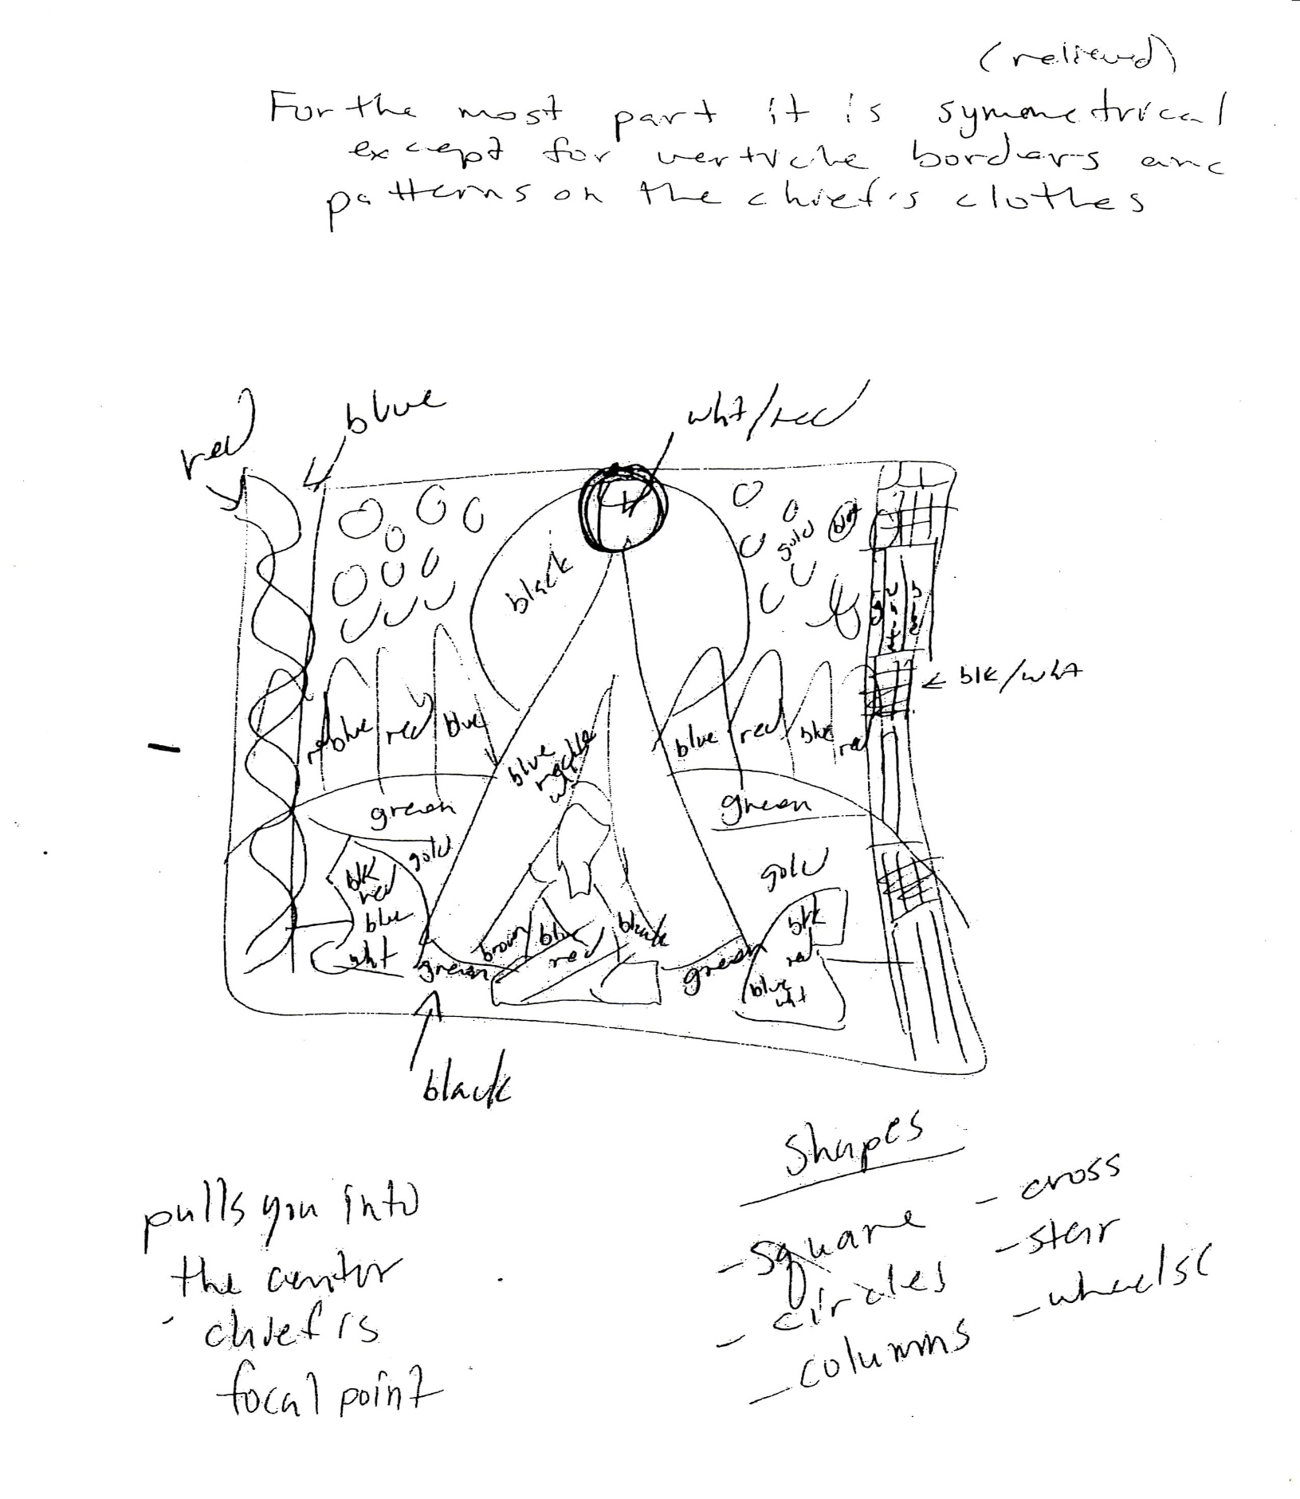

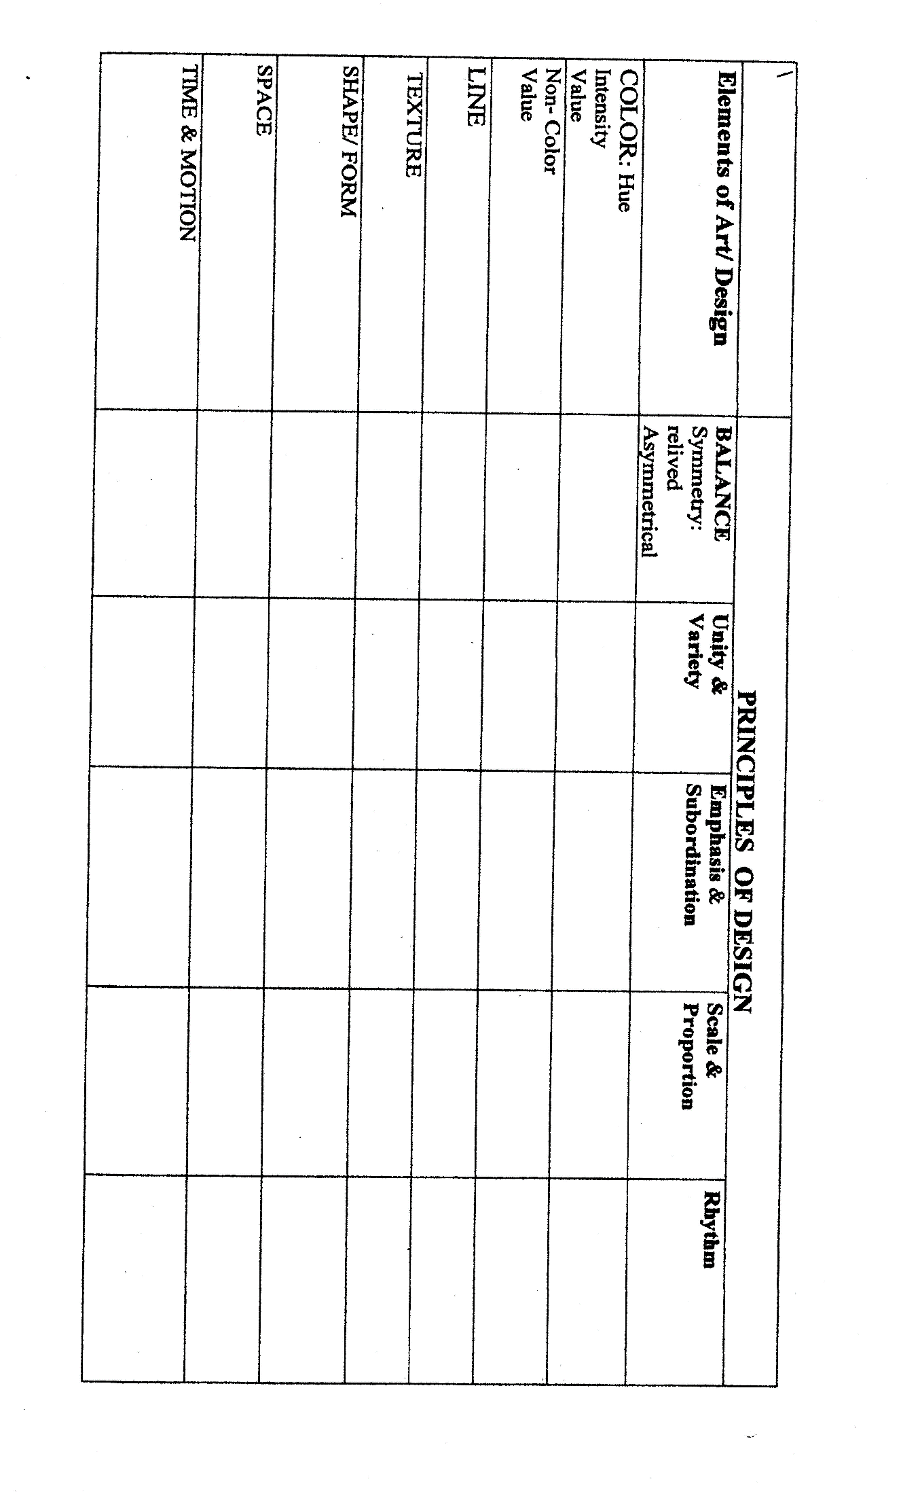
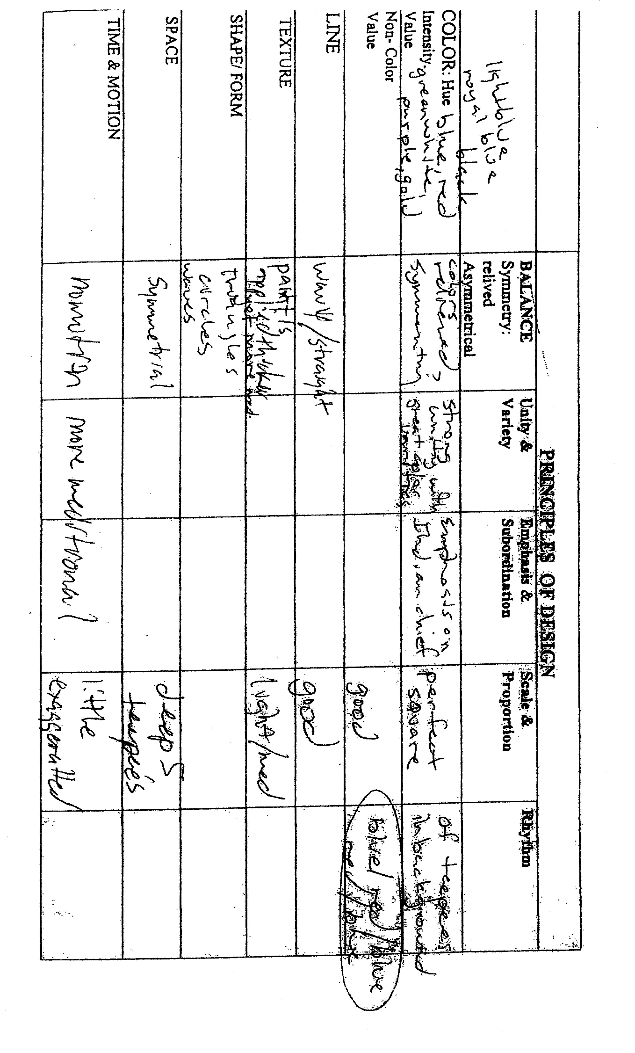

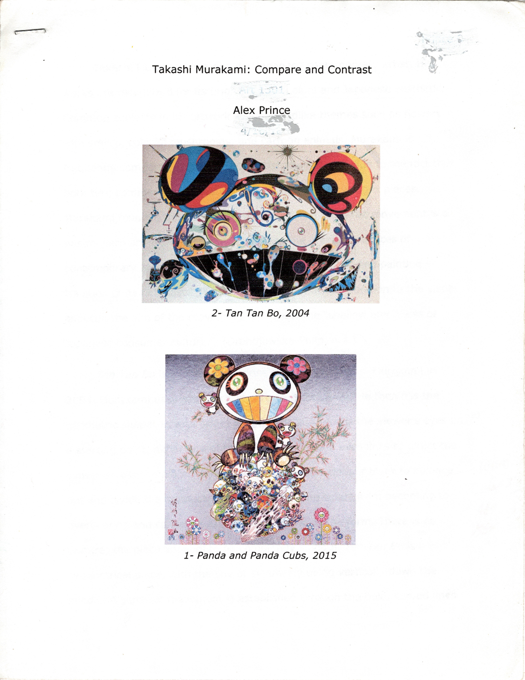

Work Cited
“Takashi Murakami (Japanese Artist).” Wikipedia, Wikimedia Foundation, 25 June 2020, en.wikipedia.org/wiki/ _(Japanese_artist).
“Takashi Murakami (Japanese, b. 1952). Cyclamen and Lemon, 1992. Oil on: Lot #75022.” Heritage Auctions, fineart.ha.com/itm/david-bates-american-b-1952-cyclamen-and-lemon-1992-oil-on-canvas-20-x-24-inches-508-x-61/a/5273-75022.s?ic13=GalleryView-ShortDescription-071515-smp.
“Takashi Murakami.” Berggruen, www.berggruen.com/exhibitions/ Takashi Murakami?view=slider.
“Takashi Murakami DC Moore Gallery, www.dcmooregallery.com/artists/ Takashi Murakami

