NORTH CENTRAL TEXAS COLLEGE

COURSE SYLLABUS

COURSE AND INSTRUCTOR INFORMATION

Course Title: Art Appreciation
Course prefix, 1301 0404
Semester/Year of course: SPRING 2024
Semester start and end dates:1/16/2024 -5/11/2024.
Modality (Face to face):
Class meeting Room 310, TTR, and 1:00-2:20 PM:
Lab meeting location, days, and times:
Semester credit hours: 3:00
Course Description: A course open to all students directed toward understanding the elements and principles of art as applied to the visual arts: painting, sculpture, and architecture as well as printmaking, ceramics, metal work and weaving. 48 lecture hours. Meets NCTC Core Curriculum Requirement.
Course prerequisites:

Course Content College-level courses may include controversial, sensitive, and/or adult material. Students are
expected to have the readiness for college-level rigor and content.

Required course materials: Living with Art 12th Edition, Mark Getlein, ed.

Name of instructor: George Moseley
Office location:
Telephone number: 940 498-6204
E-mail address: gmoseley@nctc.edu
Office hours for students: TBD

SYLLABUS CHANGE DISCLAIMER
The faculty member reserves the right to make changes to this published syllabus if it is in the best interest of the educational development of this class. Any such changes will be announced as soon as possible in person and/or writing.

SUMMARY OF COURSE ASSIGNMENTS

List of graded assignments: Your grade for this course will be determined by exams, an Art Review or Compare & contrast essay, hands-on projects, and discussion short essays.

The five grades (five exams and an art project which consists of: an Art Review and a Compare & Contrast essay) are each worth 20 %. Class participation is a must and can help with grades that border between C/B, B/A, etc.
LockDown Browser Requirement
This course requires the use of Lockdown Browser for online exams. Watch this video to get a basic understanding of Lockdown Browser:
https://www.respondus.com/products/lockdown-browser/student-movie.shtml
https://download.respondus.com/lockdown/download.php?id=433343673

*Your lowest exam grade will be dropped if you don’t have an A average after the four exams and the project is turned in.
** Note: if you have an A average going into the final exam you will be exempt from taking the final. **
The exams are a combination of textbook and presentation information.

* Hands-on Art Projects- There will be opportunities for extra credit points in the form of hands-on art projects.
Exams will include a variety of question types, including:
- short essays on artists
- Slide identification
- multiple choice.
- matching.
- True and false

Final grade scale:
A= 90 to 100
B=80 to 89
C= 70 to 79
D= 60 to 69
F= below 60

You have the choice to do one of the two projects.

PROJECT No.1- Compare and Contrast Essay 100pts. (approx. 980-1300 double-spaced typed words. Standard MLA font is usually considered to be Times New Roman or Arial. 12-point font. *Spacing, titles and illustrations do not count toward page length.
You will be assigned an artist to research whose artwork may/or may not be in the textbook "Living with Art".
You will compare/contrast two works by the artist an early work and late period artwork.
- First, spend time looking thoroughly at the work of art, and then write an analysis of it. Think in terms of subject, form, and content.
Also, include some information about the artist and the historical period he/she represented.
As you analyze, look for how the elements of art and the principles of design are used.
-How is the artist using shape, color, line, space, and texture?
-How is the piece balanced? What rhythms are established? Do you get a sense of movement? -How is the artist (he/she) using these formal aspects to help convey a mood or idea?
What do you think is the purpose of making the piece?
What do you think they were trying to say?
- Find another work by the artist (which could be similar in some way or different) and analyze the piece. For example, two still-lifes, portraits, landscapes, or works with a similar theme, like mother and child, the crucifixion, war, etc. look at both, compare, and contrast the two.
Again, think in terms of form, subject, and content. How are they similar? In what ways are they different? Be specific.
- Respond to these works of art, both critically and personally. Do you think they are equally successful as works of art? Why? How do they make you feel? Do you like them? Why or why not?
*This essay must include a cover sheet that has the following information and two-color images of the works in this order (Example of the cover page):
- Essay Title
- Art 1301
- Student's Name
- Date
- Work One: The Sower. Vincent van Gogh, 1888. Oil on canvas. 21.5 inches by 18 inches. Van Gogh Museum, Amsterdam.
- Work Two: Sugar Cane. Vincent van Gogh, 1931. Oil on canvas. 58 inches by 95 inches. Philadelphia Museum of Art.
- *This paper should have at least three sources listed in an attached bibliography, other than the text. *This paper is to be submitted electronically to Canvas to check for plagiarism.
**Compare & Contrast Essay Due Thursday, APRIL 18th.
Project No.2---Art Review 100pts. Points breakdown: Paper 75pts., Principles of Design Chart 10 pts., Checklist chart 10pts., Diagram 5pts.
The works selected for the Art Review (approx. (980-1300 double-spaced typed words.
Standard MLA font is usually considered to be Times New Roman or Arial. 10-point font.)
You can go to an art exhibition at one of the following museums (Amon Carter Museum of American Art, Dallas Museum of Art, Fort Worth Museum of Modern Art, and the Kimbell Museum of Art in Ft. Worth, TX).
-Look at an exhibition and give your overall impression of the show.
Which pieces were particularly meaningful to you?
-Does the exhibition have a theme? What kind of work does it include (Paintings, drawings, sculptures, installations, or videos)?
Describe multiple works in the exhibition. Choose a work of art you are captivated by that should be described in detail (including using the elements and principles of design).
Choose one artwork you like. Why? or why not? Choose another artwork that you liked or didn't like and briefly describe it, explain why you liked or didn't like the work.
*Note: You must submit a receipt or a brochure from the exhibition to turn in with your paper for authenticity or take a digital image of yourself at the museum.

*See the attached example diagram and charts that must be included with your paper.

Art Review (Thursday, APRIL 18th). **This paper will need to be submitted to the professor electronically to Canvas to check for plagiarism.

Late work policy: ***If the Projects are not submitted on the due date the grade for that project will drop by a letter grade and will continue to drop until submitted.

SEE CANVAS FOR THE COMPLETE COURSE CALENDAR, OUTLINE, DETAILED DESCRIPTION OF GRADED WORK, AND OTHER RELATED MATERIAL.

COURSE POLICIES
Scholastic dishonesty shall include but is not limited to cheating, plagiarism, academic falsification, intellectual property dishonesty, academic dishonesty facilitation, and collusion. Faculty members may document and bring charges against a student who is engaged in or is suspected to be engaged in academic dishonesty. See Student Handbook, "Student Rights & Responsibilities: Student Conduct ([FLB(LOCAL)]". Consequences for academic dishonesty may include 1. fail the class.
Academic Integrity Policy: Scholastic dishonesty shall include but is not limited to cheating, plagiarism, academic falsification, intellectual property dishonesty, academic dishonesty facilitation, and collusion. Faculty members may document and bring charges against a student who is engaged in or is suspected of being engaged in academic dishonesty. See Student Handbook, "Student Rights & Responsibilities: Student Conduct ([FLB(LOCAL)]". Consequences for academic dishonesty may include 1. fail the class.
Attendance Policy: Regular and punctual attendance is expected of all students in all classes for which they have registered. All absences are unauthorized unless the student is absent due to illness or emergencies as determined by the instructor. It is the student's responsibility to provide documentation as to the emergency for approval and judgement by the faculty member. Approved college-sponsored activities are the only absences for which a student should not be held liable and only when provided by a college official ahead of the absence. Valid reasons for absence, however, do not relieve the student of the responsibility for doing the required work. Students will not be allowed to make up an examination missed due to absence unless they have reasons acceptable to the instructor. A student who is compelled to be absent when a test is given should request the instructor, in advance, if possible, for permission to postpone the exam. Students will be dropped from a class by the Registrar upon recommendation of the instructor who feels the student has been justifiably absent or tardy enough times to preclude meeting the course's objectives. Persistent, unjustified absences from classes or laboratories will be considered sufficient cause for college officials to drop a student from the rolls of the College. From Board Policy FC (LOCAL)
*** You can have (2) unexcused absences. If you accumulate more unexcused absences your grade will drop by a letter grade. Every unexcused absence afterward will drop your grade another letter grade and so on, etc.
**Do not make appointments for other things during class time (they will count as absences or partial absences.)
Withdrawal Policy
A student may withdraw from a course on or after the official date of record. It is the student’s responsibility to initiate and complete a Withdrawal Request Form.
The last day to withdraw from the course with a “W” is April 1st.

Student Learning Outcomes: At the successful completion of this course the student will be able to:
- Apply art terminology as it specifically relates to works of art.
- Demonstrate knowledge of art elements and principles of design.
- Differentiate between the processes and materials used in the production of various works of art.
- Critically interpret and evaluate works of art.
- Demonstrate an understanding of the impact of art.
COLLEGE POLICIES

STUDENT HANDBOOK
Students are expected to follow all the rules and regulations found in the Student Handbook.
ADA STATEMENT
NCTC will adhere to all applicable federal, state, and local laws, regulations, and guidelines concerning providing reasonable accommodations to afford equal educational opportunity. It is the student’s responsibility to contact the Office for Students with Disabilities to arrange appropriate accommodations. See the OSD Syllabus Addendum.
DISABILITY SERVICES (Office for Students with Disabilities)
The Office for Students with Disabilities (OSD) provides support services for students with disabilities, students enrolled in technical areas of study, and students who are classified as special populations (i.e. single parents).
Support services for students with disabilities might include appropriate and reasonable accommodations, or they may be in the form of personal counseling, academic counseling, career counseling, etc. Furthermore, OSD Counselors work with students to encourage self-advocacy and promote empowerment. The Counselors also provide resource information, disability-related information, and adaptive technology for students who qualify.
If you feel you have needs for services that the institution provides, please reach out to either Wayne Smith (940) 4986207 or Yvonne Sandman (940) 668-4321. Alternative students may stop by Room 170 in Corinth or Room 110 in Gainesville.
STUDENT SERVICES
NCTC provides a multitude of services and resources to support students. See the Student Services Syllabus Addendum for a listing of those departments and links to their sites.

QUESTIONS, CONCERNS, or COMPLAINTS
The student should contact the instructor to deal with any questions, concerns, or complaints specific to the class. If the student and faculty are not able to resolve the issue, the student may contact the chair or coordinator of the division. If the student remains unsatisfied, the student may proceed to contact the instructional dean.
Name of Chair/Coordinator: Dr. Thomas Singletary, Interim Chair, Visual & Performing Arts
Office location: 2010 Performing Arts Center (Gainesville Campus)
Telephone number: (940) 668-3385
E-mail address: tsingletary@nctc.edu

Name of Instructional Dean: Crystal Wright, Interim Dean of Social and Behavioral Sciences
Office location: FSB Exchange, Denton, room 204
Telephone number: 940-380-2504
E-mail address: cwright@nctc.edu

COURSE Tentative* SCHEDULE: ART APPRECIATION Spring 2024 TTH 8:00-9:20 am

Introductory essay what makes "art" art? The text of this essay is to be at
At least 250 words 5 points.

Tell me a little about yourself and what you hope to learn in art appreciation.
Consider what you think of as "art" and then try to explain what makes it art If you do not know what you think or have never considered this before, a good starting place may be to look through your textbook and examine which pieces you respond to and why. Think about what qualities you look for when you select something to hang on your wall. What do you respond to in a work of art? Is it the way it looks, the way it makes you feel, or the ideas it suggests? This art essay is an introductory survey for me. There is no right or wrong answer, but please think about the question seriously. I would like an idea of what you think at the beginning of the course, before any instruction, you will not get these papers back. In addition to that, tell me a little about yourself and what you hope to learn in art appreciation.
Due Thursday 16th
Submit to Canvas Assignment Tab “What makes “art” art?
*By 7:30 a.m. in canvas
Week 1 January 16^{th-} 18th Introduction, Discuss Living with Art [LO: 4, 3, 2, 1]
Chapter 1 Discuss & Show examples of Living with Art, [LO: 4, 3, 2, 1]
WEEK 2 (Jan 23rd⁻ 25) Discuss and show examples of What is Art? [LO: 4, 3, 2, 1] Discuss, define & show examples of Themes and Purposes of Art, [LO: 1, 2, 3, and 4]
WEEK 3 (Jan 30- Feb 1st) Show examples of Themes and Purposes of Art, [LO: 1, 2, 3, and 4]
Chapter 3 Discuss, define & show examples of The Vocabulary of Art [LO: 1, 2, 3, and 4]
WEEK 4 (Feb 6th-8th) Chapter 4 Discuss, define & show examples of Visual Elements
*Exam#1 Thursday, Feb 8th
Week 5 (Feb 13-15th)
Discuss, define & show examples of Principles of Design, [LO: 1, 2, 3,4,]
WEEK 6 - (Feb 20th -22)
Two-Dimensional Media
Drawing -Discuss & show examples of drawing media/techniques, [LO: 1, 2, 3, 4, and 5]
WEEK 7 (Feb 27 – Feb 29) Chapter 8- Prints, Discuss & show examples of printmaking processes, [LO: 1, 2, 3, and 4]
Painting Discuss & show examples of painting media and techniques, [LO: 1, 2, 3,]
Week 8 (March 5-7th) Chapter 7-Painting Discuss & show examples of painting media and techniques, [LO: 1, 2, 3, and 4] Continuation of Painting
*** Exam#2 Thursday, March 7th
MARCH 11-16 SPRING BREAK
WEEK 9 (March 19 -21) Discuss, define, and show examples of Camera Arts: Photography, [LO: 1, 2, 3, and 4]
WEEK 10 (March26th -28)
Discuss, define, and show examples of Camera Arts: Photography, [LO: 1, 2, 3, and 4]
Introduce Discuss, define, and show examples of Cinematography & Video Art, [LO: 1, 2, 3, and 4]
WEEK 11 (April 2 -4) Continuation of Cinematography & Video Art
Discuss, define, and show examples of Graphic Design & Illustration Continuation of Graphic Design and Illustration
***Exam#3 Thursday April 4th
WEEK 12 (April 9th -11th) Three-Dimensional Media: Sculpture and Installations
Discuss, define, and show examples of Sculpture & the methods artists use to create them. [LO: 1, 2, 3, and 4]
WEEK 13 April 16-18 Discuss, define, and show examples of Art of Daily Life: Crafts: Clay, Glass, Metal, Wood, Fiber, and Jade & Lacquer, Blurring the boundaries: Artists and Crafts. [LO: 1, 2, 3, and 4]
Discuss, define, and show examples of the evolution of Architecture: Structural systems, Purpose of, and environmental design [LO: 1, 2, 3, and 4]
***Compare & Contrast Essay Due Thursday April 18th or * ** Art Review (Due Thursday, April 18th)
**This paper will need to be submitted electronically to Canvas to check for plagiarism.
WEEK 14 (April 23rd – 25th)
Discuss, define, and show examples of the evolution of Architecture: Structural systems, Purpose of, and environmental design [LO: 1, 2, 3, and 4]
***Exam# 4 Thursday 25th
WEEK 15 (April 30th – May 2nd)
Chapter 14 Discuss, define, and show examples of art in Ancient Mediterranean Worlds: The Oldest Art, Mesopotamia, Egypt, the Aegean, Greece, & Rome [1, 2, 3, 4]
WEEK 16 (May 6th – 11th)
Finals are scheduled for the week of May 6-11, 2024.
Please schedule your final exam during the specified dates. Dean's approval is required for final exams to be offered on an alternate date.
MONDAY - WEDNESDAY CLASSES
Regular Class Time Exam Final time
1:00-2:20 p.m. May 7th 2:00-3:50 p.m.

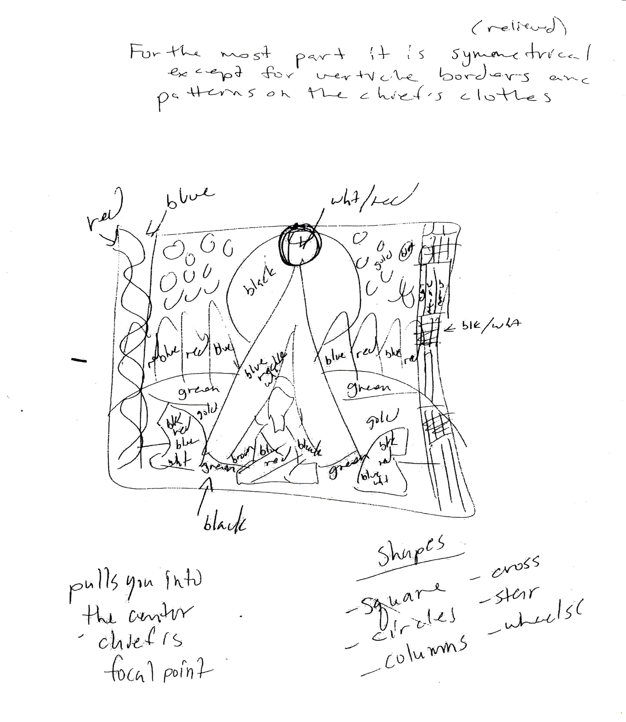

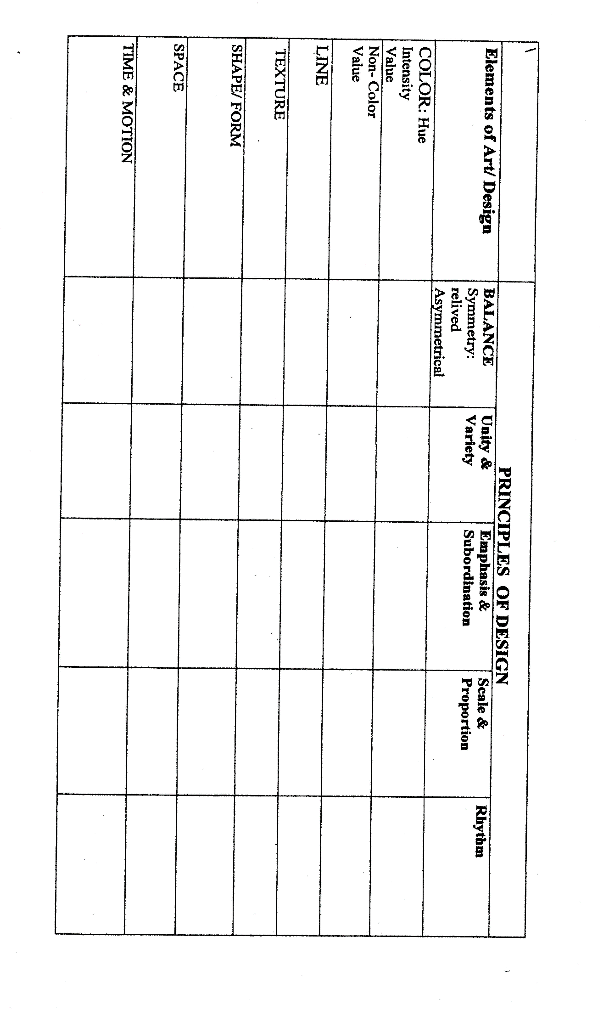
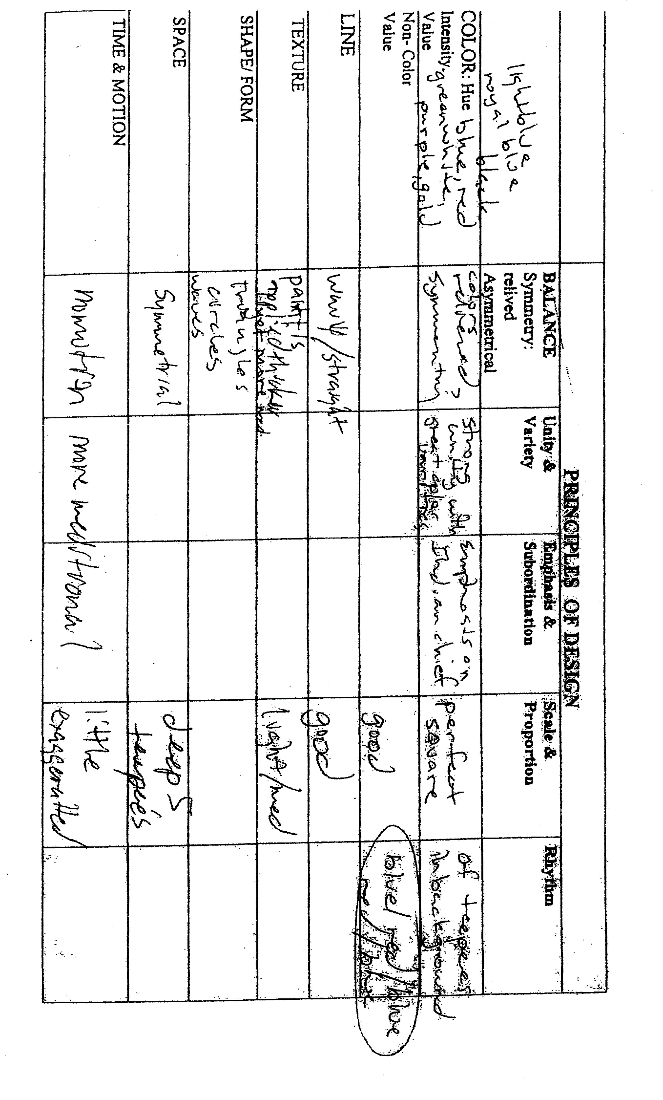

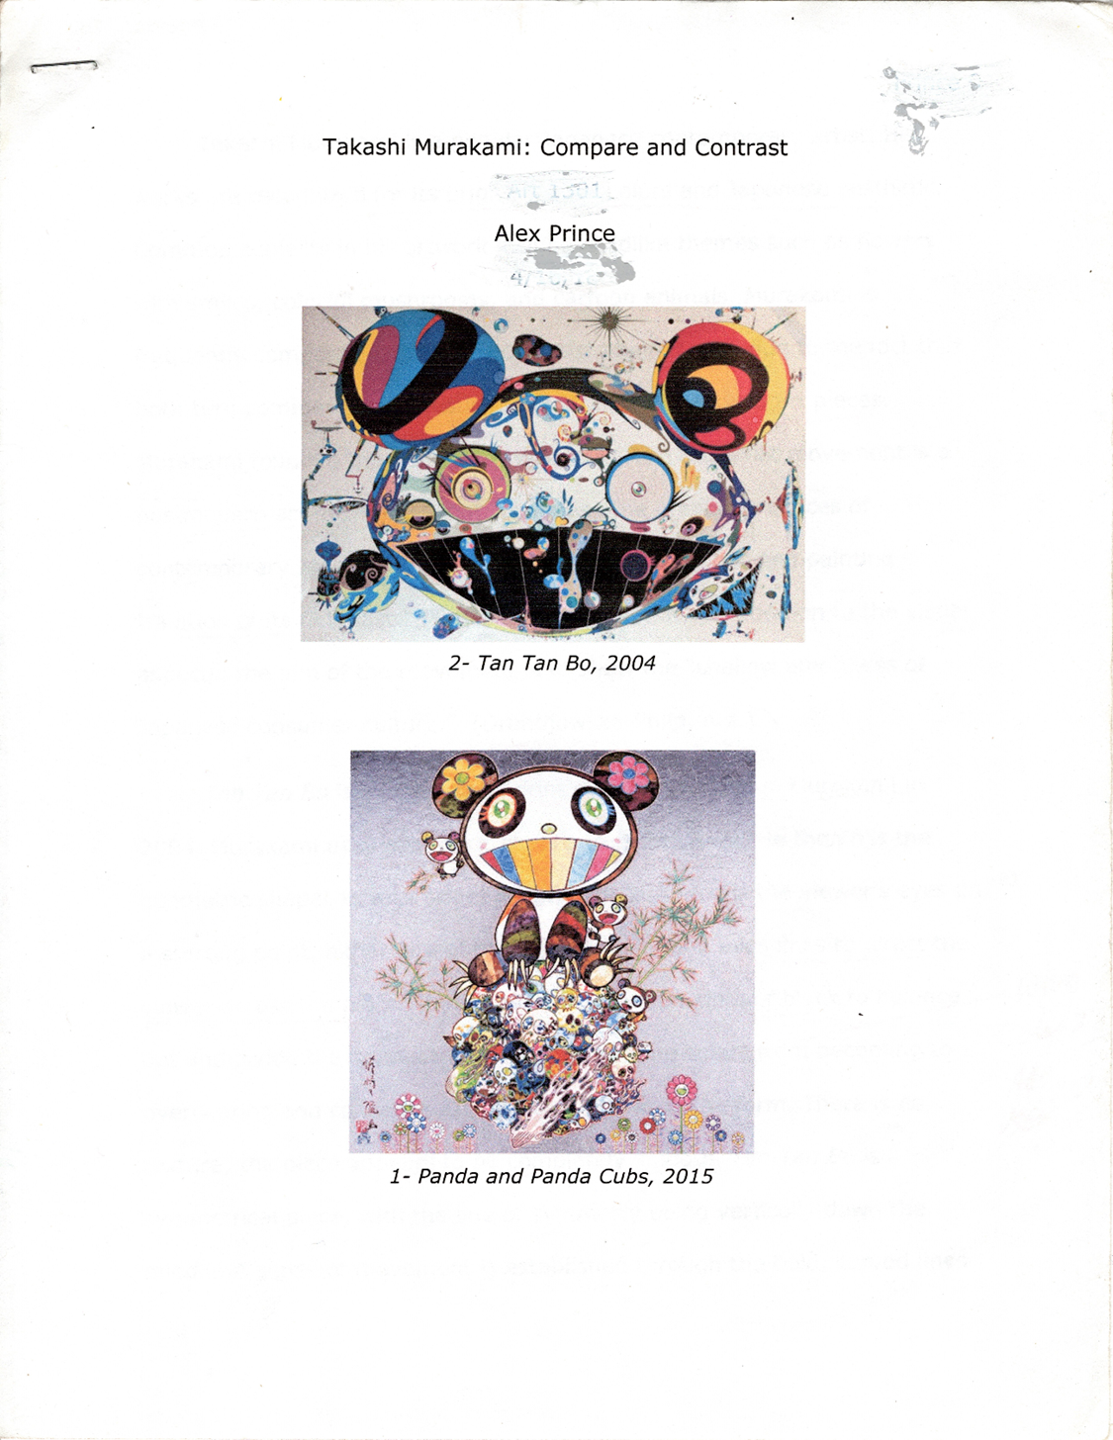

Work Cited
“Takashi (Japanese Artist).” Wikipedia, Wikimedia Foundation, 25 June 2020, en.wikipedia.org/wiki/Takashi Japanese_artist).
“Takashi (Japanese, b. 1952). Tan Tan Bo, 2004. Oil on: Lot #75022.” Heritage Auctions, fineart.ha.com/itm/ -oil-on-canvas-20-x-24-inches-508-x-61/a/5273-75022.s?ic13=GalleryView-ShortDescription-071515-smp.
“Kakashi Berggruen, www.berggruen.com/exhibitions/david-bates4?view=slider.
“Kakashi.” DC Moore Gallery, www.dcmooregallery.com/artists/Kakashi

