NORTH CENTRAL TEXAS COLLEGE
COURSE SYLLABUS

Course Title: | U.S. History from 1865
Course Prefix & Number: |  | HIST1302 | Section Number: | 503 | Semester/Year: | Fall/2018
Semester Credit Hours: |  | 3 | Lecture Hours: | 3 | Lab Hours: | 0
Course Description (NCTC Catalog):
A survey of the social, political, economic, cultural, and intellectual history of the United States from the Civil War/Reconstruction era to the present. United States History II examines industrialization, immigration, world wars, the Great Depression, Cold War and post-Cold War eras. Themes that may be addressed in United States History II include: American culture, religion, civil and human rights, technological change, economic change, immigration and migration, urbanization and suburbanization, the expansion of the federal government, and the study of U.S. foreign policy.
Course Prerequisite(s): None
Required or Recommended Course Materials:
Brinkley, Alan, The Unfinished Nation: A Concise History of the American People. 8th edition. McGraw-Hill. 2016. ISBN #987-1259959126

The web-based material is unique to NCTC. You must purchase it from the NCTC bookstore or directly from McGraw-Hill publishing.
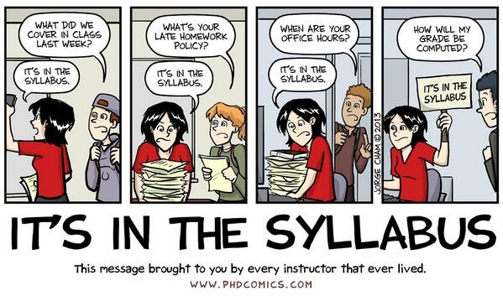
INSTRUCTOR INFORMATION
Name of Instructor: | Professor Charles Adams
Campus/Office Location: | Flower Mound
Telephone Number: | 972-899-8424
E-mail Address: | cadams@nctc.edu

OFFICE HOURS
Monday | Tuesday | Wednesday | Thursday | Friday
12:30pm-4:30pm | 12:30pm-4:30pm | 12:30pm-4:30pm

STUDENT LEARNING OUTCOMES (From Academic Course Guide Manual/Workforce Education Course Manual/NCTC Catalog
At the successful completion of this course the student will be able to:
Create an argument through the use of historical evidence.
Analyze and interpret primary and secondary sources.
Analyze the effects of historical, social, political, economic, cultural, and global forces on this period of United States history.

GRADING CRITERIA
# of Graded Course Elements | Graded Course Elements | Percentage or Point Values
1 | Researching Primary and Secondary Sources | 100
1 | Essay | 100
1 | Midterm Examination | 200
1 | Primary Source Evaluation | 150
1 | Twitter War | 100
15 | Quizzes | 150 (15*10 points)
1 | Final Examination | 200
 | Total Points | 1000

ASSIGNMENT DESCRIPTIONS
- Researching Primary and Secondary Sources
The student will research and identify a primary source relevant to the class and cite the source using the proper Chicago style citation. The student then will utilize JSTOR and find a secondary source which they will also identify using the proper Chicago style citation and provide a one paragraph summary explaining how the primary source is used in the secondary writing. Maximum score = 100

- Essay
The student will submit a 600 word or longer, persuasive essay based on a source or sources provided for the assignment. This essay will be used to determine the student’s ability to identify and analyze key points in historical primary source documents. It will be presented in a formal essay form with an introduction, body, and a conclusion. Maximum score = 100

- Midterm
Covers Topics discussed in the first half of the semester (see Topic Breakdown & Reading Assignments). This in-class exam will consist of 27 multiple choice problems, 10 fill the blank, and five analytical short answer questions. Maximum score = 200

- Primary Source Evaluation
The student will engage in a detailed evaluation of a primary source provided by the instructor and then answer a series of questions that provide a deep analysis of the primary source, its meaning, and its significance. Maximum score = 150

- Mock Twitter Battle
The student will be required to create a fictitious Twitter battle between historical figures choosing from a list of participants and topics provided. They will have to discuss both ends of the topic from the position likely taken by the historical participant. Maximum score = 100

- Topic Quizzes (15 Total)
Upon the completion of every topic block (see Tentative Class Schedule and Reading Assignments), you will be required to take a multiple choice quiz on Blackboard. Quizzes will consist of 10 multiple choice questions. You may attempt each quiz as many times as you like. The highest score will be retained as your quiz grade so that a reattempt the scores lower will not replace that highest grade. All quizzes count to your grade total so it is important to be sure to get all quizzes completed. Quiz scoring count only up to the maximum points. Maximum score = 150

- Final Exam
Covers Topics discussed in the second half of the semester (see Topic Breakdown & Reading Assignments). This in-class exam will consist of 27 multiple choice problems, 10 fill the blank, and five analytical short answer questions. Maximum score = 200.

COURSE SUBJECT OUTLINE (Major Assignments, Due Dates, and Grading Criteria)
Researching Primary and Secondary Sources | 3 February 11:59pm | 100 pts.
Essay | 3 March 11:59pm | 100 pts. – See Rubric
Midterm | 7 March 8:00am | 200pts.
Primary Source Evaluation | 7 April 11:59pm | 150 pts
Twitter War | 21 April 11:59pm | 100 pts
Quizzes | 13 May 11:59pm | 10 pts each – 150 maximum points
Final | 14 May 8:00am-9:50am | 200pts. – 50pts mult. choice  50pts fill the blank  100pts short answer

Final Grade | Total Percent Earned
A | 89.5% to 100%
B | 79.5% to 89.4%
C | 69.5% to 79.4%
D | 59.5% to 69.4%
F | 0 to 59.4%

LATE WORK POLICY
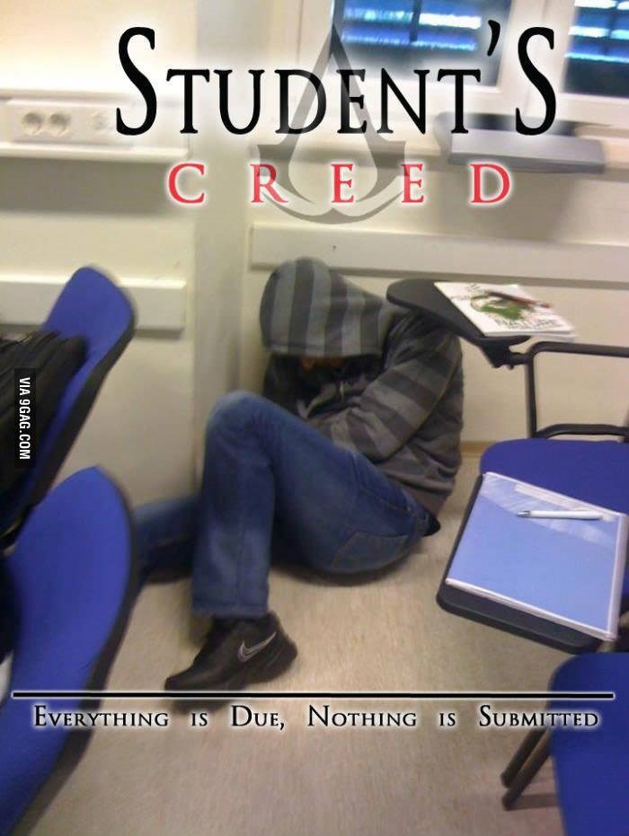
BE SURE TO PAY CLOSE ATTENTION TO DEADLINES!!
Make ups will not be scheduled without a serious and compelling reason and the Instructor’s approval. Be aware that any granted make-up may, solely at the discretion of the Instructor, be a different format than the regularly scheduled item (i.e. Make up exams may be composed entirely of essay questions as opposed to multiple-choice).

ATTENDANCE POLICY
Regular and punctual attendance is expected of all students in all classes for which they have registered. All absences are considered to be unauthorized unless the student is absent due to illness or emergencies as determined by the instructor. It is the student responsibility to provide documentation as to the emergency for approval and judgement by the faculty member. Approved college sponsored activities are the only absences for which a student should not be held liable and only when provided by a college official ahead of the absence. Valid reasons for absence, however, do not relieve the student of the responsibility for making up required work. Students will not be allowed to make up an examination missed due to absence unless they have reasons acceptable to the instructor. A student who is compelled to be absent when a test is given should petition the instructor, in advance if possible, for permission to postpone the exam. Student will be dropped from a class by the Registrar upon recommendation of the instructor who feels the student has been justifiably absent or tardy a sufficient number of times to preclude meeting the course’s objectives. Persistent, unjustified absences from classes or laboratories will be considered sufficient cause for College officials to drop a student from the rolls of the College. From Board Policy FC (LOCAL)
Last day to withdraw from a course with a “W” is _4 April 2019_.

DISABILITY SERVICES (Office for Students with Disabilities)
The Office for Students with Disabilities (OSD) provides support services for students with disabilities, students enrolled in technical areas of study, and students who are classified as special populations (i.e. single parents).
Support services for students with disabilities might include appropriate and reasonable accommodations, or they may be in the form of personal counseling, academic counseling, career counseling, etc. Furthermore, OSD Counselors work with students to encourage self-advocacy and promote empowerment. The Counselors also provides resource information, disability-related information, and adaptive technology for students who qualify.
If you feel you have needs for services that the institution provides, please reach out to either Wayne Smith (940) 498-6207 or Yvonne Sandman (940) 668-4321. Alternative students may stop by Room 170 in Corinth or Room 110 in Gainesville.
CORE CURRICULUM FOUNDATIONAL COMPONENT AREA (For classes in the Core)________

o Communication
o Mathematics
o Life and Physical Science
o Language, Philosophy & Culture
o Creative Arts
X American History

o Government/Political Science
o Social and Behavioral Sciences
o Component Area Option

REQUIRED CORE OBJECTIVES (For classes in the Core)

X Critical Thinking
X Communication
o Empirical and Quantitative

o Teamwork
X Personal Responsibility
X Social Responsibility

COURSE TYPE
o Academic General Education Course (from ACGM but not in NCTC Core)
X Academic NCTC Core Curriculum Course
o WECM Course

STUDENT HANDBOOK
Students are expected to follow all rules and regulations found in the student handbook and published online.

ACADEMIC DISHONESTY
Scholastic dishonesty shall include, but is not limited to cheating, plagiarism, academic falsification, intellectual property dishonesty, academic dishonesty facilitation and collusion. Faculty members may document and bring charges against a student who is engaged in or is suspected to be engaged in academic dishonesty.
Consequences for academic dishonesty may include:
- Failure of the assignment.
- Failure of the class.
CLASSROOM DECORUM
Disruptive students in the academic setting hinder the educational process. Examples include, but are not limited to persistently speaking without being recognized or interrupting other speakers; behavior that distracts the class from the subject matter or discussion; or in extreme cases, physical threats, harassing behavior or personal insults, or refusal to comply with faculty direction. Any behavior that adversely affects the normal educational functioning or the professional standards of the class may result in failure for the course.
Cell phones, and other media devices are a significant distraction and MUST BE TURNED OFF or PUT IN SILENT MODE (VIBRATE MODE IS NOT ACCEPTABLE) prior to coming to class. Do not answer phones during class. Do not text during class. If you are expecting an emergency phone call, you MUST make arrangements with your instructor prior to class. Those using a cell phone MUST leave the classroom for the remainder of the class period. Laptops and tablets are permitted for note taking during lecture only. MP3 players and other portable electronic devices are not permitted in class. Headphones of any kind are strictly prohibited in the classroom. Students who repeatedly violate this policy may be dropped from the class.

QUESTIONS, CONCERNS, or COMPLAINTS
Name of Chair/Coordinator: | Crystal R.M. Wright
Office Location: | Gainesville Campus, Room 824
Telephone Number: | 940-668-7731, ext. 4320
E-mail Address: | cwright@nctc.edu
Name of Instructional Dean: | Dr. Bruce King
Office Location: | 1525 W. California St., Gainesville, Texas
Telephone Number: | 940-668-4267
E-mail Address: | bking@nctc.edu

Course Summary:

Date | Details
Sun Feb 3, 2019 | Researching Primary and Secondary Sources due by 11:59pm
Sun Mar 3, 2019 | Essay Assignment due by 11:59pm
Thu Mar 7, 2019 | Midterm Examination due by 8am
Sun Apr 7, 2019 | Primary Source Evaluation due by 11:59pm
Sun Apr 21, 2019 | Mock Twitter Battle due by 11:59pm
Mon May 13, 2019 | Ch 15 Quiz due by 11:59pm  Ch 16 Quiz due by 11:59pm  Ch 17 Quiz due by 11:59pm  Ch 18 Quiz due by 11:59pm  Ch 19 Quiz due by 11:59pm  Ch 20 Quiz due by 11:59pm  Ch 21 Quiz due by 11:59pm  Ch 22 Quiz due by 11:59pm  Ch 23 Quiz due by 11:59pm  Ch 24 Quiz due by 11:59pm  Ch 25 Quiz due by 11:59pm  Ch 26 Quiz due by 11:59pm  Ch 27 Quiz due by 11:59pm  Ch 28 Quiz due by 11:59pm  Ch 29 Quiz due by 11:59pm  Ch 30 Quiz due by 11:59pm
Tue May 14, 2019 | Final Examination due by 8am

