NORTHCENTRAL TEXAS COLLEGE
Art Appreciation
Course Syllabus
Course No. 1301 0321 Summer II 2021 MTWR 9:30 AM-11:50 AM online using WebEx.
*Access WebEx before the first session to download the WebEx plug-in. Be aware of hardware/software requirements.

Semester Credit Hours: 3 Lecture Hours: 48 7/14/2020-8/19/2021
Course Description;
A course open to all students directed toward understanding the elements and principles of art as applied to the visual arts: painting, sculpture, and architecture as well as printmaking, ceramics, metalwork, and weaving.
Course Content: College-level courses may include controversial, sensitive, and/or adult material. Students are expected to have the readiness for college-level rigor and content.

Course Prerequisites: none
Course Type: Academic NCTC Core Curriculum Course
Instructor: George Moseley Corinth Campus / Room 201 Telephone Number: 940 498-6204

E-mail Address: Gmoselev@nctc.edu ***Email is the best way to contact me; if a message is time-sensitive, flag it as urgent.*
Office Hours: Available MTWT online 12:00 p.m.-l:00 p.m.

Chair/Coordinator: Thom Talbott
Office Location: CPA 20018 TelephoneNo.:940-6883324
EmailAddress:talbott@nctc.edu
Instructional Dean Sara Flusche
Office Location: Room 305 Telephone No:940-668-4267

E-mail Address: sflusche@nctc.edu

Required or Recommended Course Materials: Living with Art 11th Edition, Mark Getlein, ed.
* online Exams.

STUDENT LEARNING OUTCOME
At the successful completion of this course the student will be able to:
- Apply art terminology as it specifically relates to works of art.
- Demonstrate knowledge of art elements and principles of design.
- Differentiate between the processes and materials used in the production of various works of art.
- Critically interpret and evaluate works of art.
- Demonstrate an understanding of the impact of art.
Assignments and Grades:
Your grade for this course will be determined by exams, an Art Review or Compare & contrast essay, hands-on projects, and short essays.

The five grades (five exams and an art project which consists of: an Art Review and a Compare & Contrast essay) are each worth 20 %. Class participation is a must and can help with grades that border between C/B, B/A, etc.
You can drop your lowest exam grade before the project is due.
** Note: if you have an A average going into the final exam you will be exempt from taking the final. **
The exams are a combination of textbook and presentation information.
* Hands-on Art Projects- There will be opportunities for extra credit points in the form of hands-on art projects.
Exams will include a variety of question types, including:
- short essays on artists
- Slide identification
- multiple choice;
- matching;
- True and false

Grading Scale: A= 90 to 100
B=80 to 89
C= 70 to 79
D= 60 to 69
F= below 60

You have the choice to do one of the two projects.

**TWO ART PROJECTS - Compare and Contrast Essay 100pts. (approx. 950-1200 doubled spaced typed words. Standard MLA font is usually considered to be Times New Roman or Arial. 10-point font.
PROJECT No.1- Compare and Contrast Essay 100% (approx. 955-1200 doubled spaced typed words. Standard MLA font is usually considered to be Times New Roman or Arial. 12-point font. *Spacing, titles and illustrations do not count toward page length.
Each student will be assigned an artist to research whose artwork may/or may not be in the textbook "Living with Art".
You will compare/contrast two works by the artist an early work and late period artwork.
- First, spend time looking thoroughly at the work of art, and then write an analysis of it. Think in terms of subject, form, and content.
Also, include some information about the artist and the historical period he/she represented.
As you analyze, look for how the elements of art and the principles of design are used.
-How is the artist using shape, color, line, space, and texture?
-How is the piece balanced? What rhythms are established? Do you get a sense of movement? -How is the artist (he/she) using these formal aspects to help convey a mood or idea?
What do you think is the purpose of making the piece?
What do you think they were trying to say?
- Find another work by the artist (could be similar in some way or different) and analyze the piece. For example, two still-life's, portraits, landscapes, or works with a similar theme, like mother and child, the crucifixion, war, etc. look at both, compare, and contrast the two.
Again, think in terms of form, subject, and content. How are they similar? In what ways are they different? Be specific.
- Respond to these works of art, both critically and personally. Do you think they are equally successful as works of art? Why? How do they make you feel? Do you like them? Why or why not?
*This essay must include a cover sheet that has the following information and two-color images of the works in this order (Example of the cover page):
- Essay Title
- Art 1301
- Student's Name
- Date
- Work One: The Sower. Vincent van Gogh, 1888. Oil on canvas. 21.5 inches by 18 inches. Van Gogh Museum, Amsterdam.
- Work Two: Sugar Cane. Vincent van Gogh, 1931. Oil on canvas. 58 inches by 95 inches. Philadelphia Museum of Art.
- *This paper should have at least three sources listed in an attached bibliography, other than the text. *This paper will need to be submitted in writing (hard copy) to the professor, and electronically to Canvas to check for plagiarism.
**Compare & Contrast Essay Due Monday, Aug10th.
Project No.2---Art Review 100pts. The works selected for the Art Review (approx. (950-1200 doubled spaced typed words. Standard MLA font is usually considered to be Times New Roman or Arial. 10-point font.)
Go to an art exhibition at a museum (Amon Carter Museum of American Art, Dallas Museum of Art, Fort Worth Museum of Modern Art, Kimbell Museum of Art in Ft. Worth, TX).
-Look at an exhibition and give your overall impression of the show.
- Which pieces were particularly meaningful to you?
-Does the exhibition have a theme? What kind of work does it include (Paintings, drawings, sculptures, installations, or videos)?
Choose two works of art to describe in detail (include elements and principles of design). The artwork you are captivated by should be described more in detail.
Choose one artwork you like? Why? or why not? Choose another artwork that you liked or didn't like and briefly describe it, explain why you liked or didn't like the work.
*Note: Bring back a receipt or a brochure from the exhibition to turn in with your paper for authenticity or take a digital image of yourself at the museum.
*See the attached example diagram and charts that must be included with your paper.

Art Review (Due Monday, Aug10th). **This paper will need to be submitted in writing (hard copy) to the professor, and electronically to Canvas to check for plagiarism.
***If the Projects are not submitted on the due date the grade for that project will drop by a letter grade and will continue to drop until submitted.
ATTENDANCE POLICY
Regular and punctual attendance is expected of all students in all classes for which they have registered. All absences are considered to be unauthorized unless the student is absent due to illness or emergencies as determined by the instructor. It is the student responsibility to provide documentation as to the emergency for approval and judgment by the faculty member. Approved college-sponsored activities are the only absences for which a student should not be held liable and only when provided by a college official ahead of the absence. Valid reasons for absence, however, do not relieve the student of the responsibility for making up required work. Students will not be allowed to make up an examination missed due to the absence unless they have reasons acceptable to the instructor. A student who is compelled to be absent when a test is given should petition the instructor, in advance if possible, for permission to postpone the exam. The student will be dropped from a class by the Registrar upon recommendation of the instructor who feels the student has been justifiably absent or tardy a sufficient number of times to preclude meeting the course's objectives. Persistent, unjustified absences from classes or laboratories will be considered sufficient cause for College officials to drop a student from the rolls of the College. From Board Policy FC (LOCAL)
**Do not make appointments for other things during class time (they will count as absences or partial absences.) Last day to withdraw from a course with a "W" is August 5th.
Makeup Policy: Students must have verifiable medical, legal, or school excuses to receive participation grade. Makeup exams must be completed within three days of the scheduled date in the Testing Center in Room 219. The makeup exam needs to be scheduled 24hrs in advance prior and bring a photo ID.
DISABILITY SERVICES (Office for Students with Disabilities)
The Office for Students with Disabilities (OSD) provides support services for students with disabilities, students enrolled in technical areas of study, and students who are classified as special populations (i.e. single parents).
Support services for students with disabilities might include appropriate and reasonable accommodations, or they may be in the form of personal counseling, academic counseling, career counseling, etc. Furthermore, OSD Counselors work with students to entourage self- advocacy and promote empowerment. The Counselors also provides resource information, disability-related information, and adaptive technology for students who qualify.
If you feel you have needs for services that the institution provides, please reach out to either Wayne Smith (940) 4986207 or Yvonne Sandman (940) 668-4321. Alternative students may stop by Room 170 in Corinth or Room 110 in Gainesville.
STUDENT HANDBOOK
Students are expected to follow all rules and regulations found in the student handbook and published online.
Cell PHONES/ OTHER TECHNOLOGY: Laptops/tablets are acceptable for notetaking. DO NOT have your phone out during class.
ACADEMIC DISHONESTY
Scholastic dishonesty shall include but is not limited to cheating, plagiarism, academic falsification, intellectual property dishonesty, academic dishonesty facilitation, and collusion. Faculty members may document and bring charges against a student who is engaged in or is suspected to be engaged in academic dishonesty. See Student Handbook, "Student Rights & Responsibilities: Student Conduct ([FLB(LOCAL)]". Consequences for academic dishonesty may include:
1.fail the class.

For questions or concerns please contact the Office of Vice President of Student Services at
940.668.4240.

ART APPRECIATION SUMMER 1I
COURSE Tentative* SCHEDULE:
UNIT I Introduction
Introductory essay what makes "art" art? The text of this essay is to be at least 250 words 5 points.
Tell me a little about yourself and what you hope to learn in art appreciation.

Consider what you think of as "art" and then try to explain what makes it art If you do not know what you think or have never considered this before, a good starting place may be to look through your textbook and examine which pieces you respond to and why. Think about what qualities you look for when you select something to hang on your wall. What do you respond to in a work of art? Is it the way it looks, or the way it makes you feel or the ideas it suggests? This essay on art is an introductory survey for me. There is no right or wrong answer, but please think about the question seriously. I would like an idea of what you think at the beginning of the course, before any instruction, you will not get these papers back. In addition to that, tell me a little about yourself and what you hope to learn in art appreciation

Week Date Activities

WK 1 July 14-22 (EXAM I, July 22nd)
Chapter 1-Dlscuss & Show examples of Living with Art, [LO: 4, 3, 2,1]
Chapter 2-Dlscuss & Show examples of What Is Art? [LO: 4, 3, 2,1]
Chapter 3 Discuss, define & show examples of Themes and Purposes of Art, [LO: 1, 2, 3, 4]
Chapter 4- Discuss, define & show examples of Visual Elements, [LO: 1, 2, 3, 4,] J
Chapter 5-Dlscuss, define & show examples of Principles of Design, [LO: 1, 2, 3, 4,]

WK 2 July 26-29 (EXAM II July 29th)
Chapter 5-Dlscuss, define & show examples of Principles of Design, [LO: 1, 2, 3,4,]
Chapter 6- Drawing Discuss & show examples of drawing media / techniques, [LO: 1, 2, 3,
4, 5]
Chapter 8- Prints, Discuss & show examples of printmaking processes, [LO: 1, 2, 3, 4]
Chapter 7-Palntlng Discuss & show examples of painting media and techniques, [LO: 1, 2, 3,4,]
WK 3 August 2-5 (EXAM III August 6th )
Chapter 9- Discuss, define, and show examples of Camera Arts: Photography, [LO: 1, 2, 3, 4]
Chapter 9-Dlscuss, define, and show examples of Cinematography & Video Art, [LO: 1, 2, 3, 4]
Chapter 10-Dlscuss, define, and show examples of Graphic Design & Illustration, [LO: 1, 2, 3, 4]

WK 4 August 10-13 (ART Review Museum paper or Compare & Contrast essay paper DUE August 10th)

(EXAM IV August 13)
Chapter 11- Discuss, define, and show examples of Sculpture & Installations., [LO: 1, 2, 3, 4]
Chapter 12- Discuss, define, and show examples of Arts of Ritual and Dally Life, [LO: 1, 2, 3,]
Chapter 13-Dlscuss, define, and show examples of the evolution of Architecture: Structural systems, Purpose of, & Environmental design, [LO: 1, 2, 3, 4]

WK 5 August 16- 19th (FINAL EXAM August 19th)

Chapter 14
Discuss, define, and show examples art in Ancient Mediterranean worlds: The Oldest Art, Mesopotamia, Egypt, the Aegean, Greece, & Rome, [1, 2, 3, 4]

Chapter 15
Discuss, define, and examples relevant to Christianity and the formation of Europe: Byzantine, Middle Ages (early & high) in Europe, the move the Renaissance, [LO: 1, 2, 3, 4

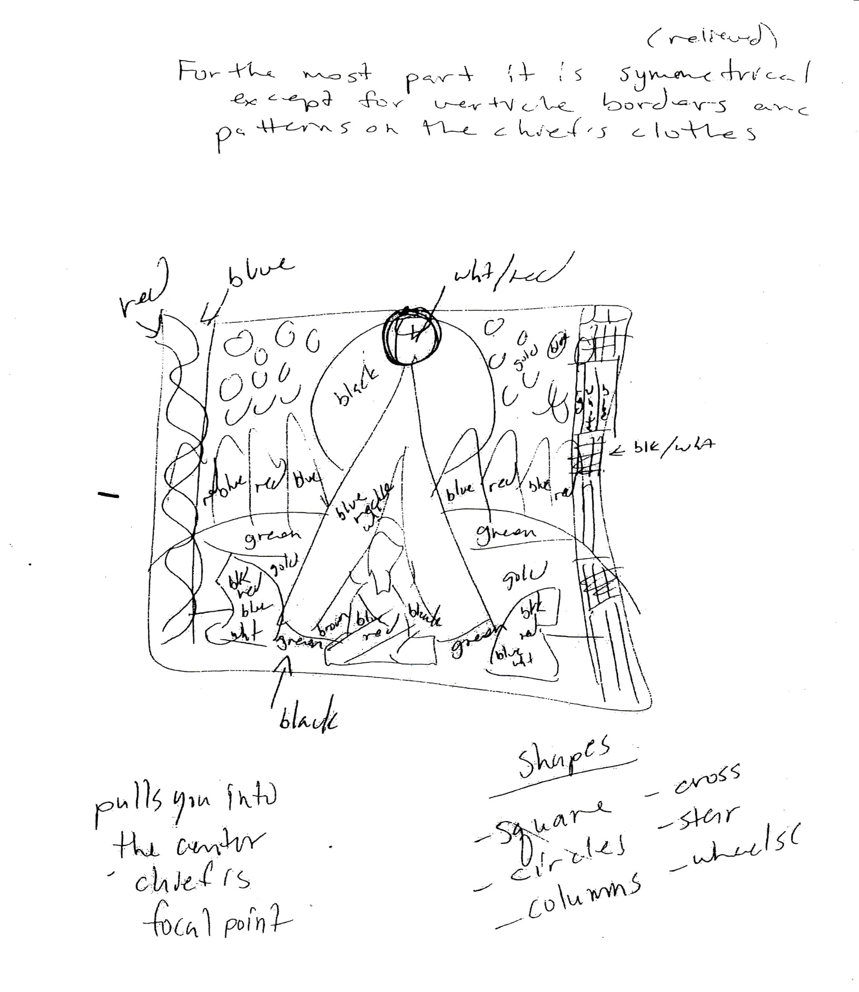

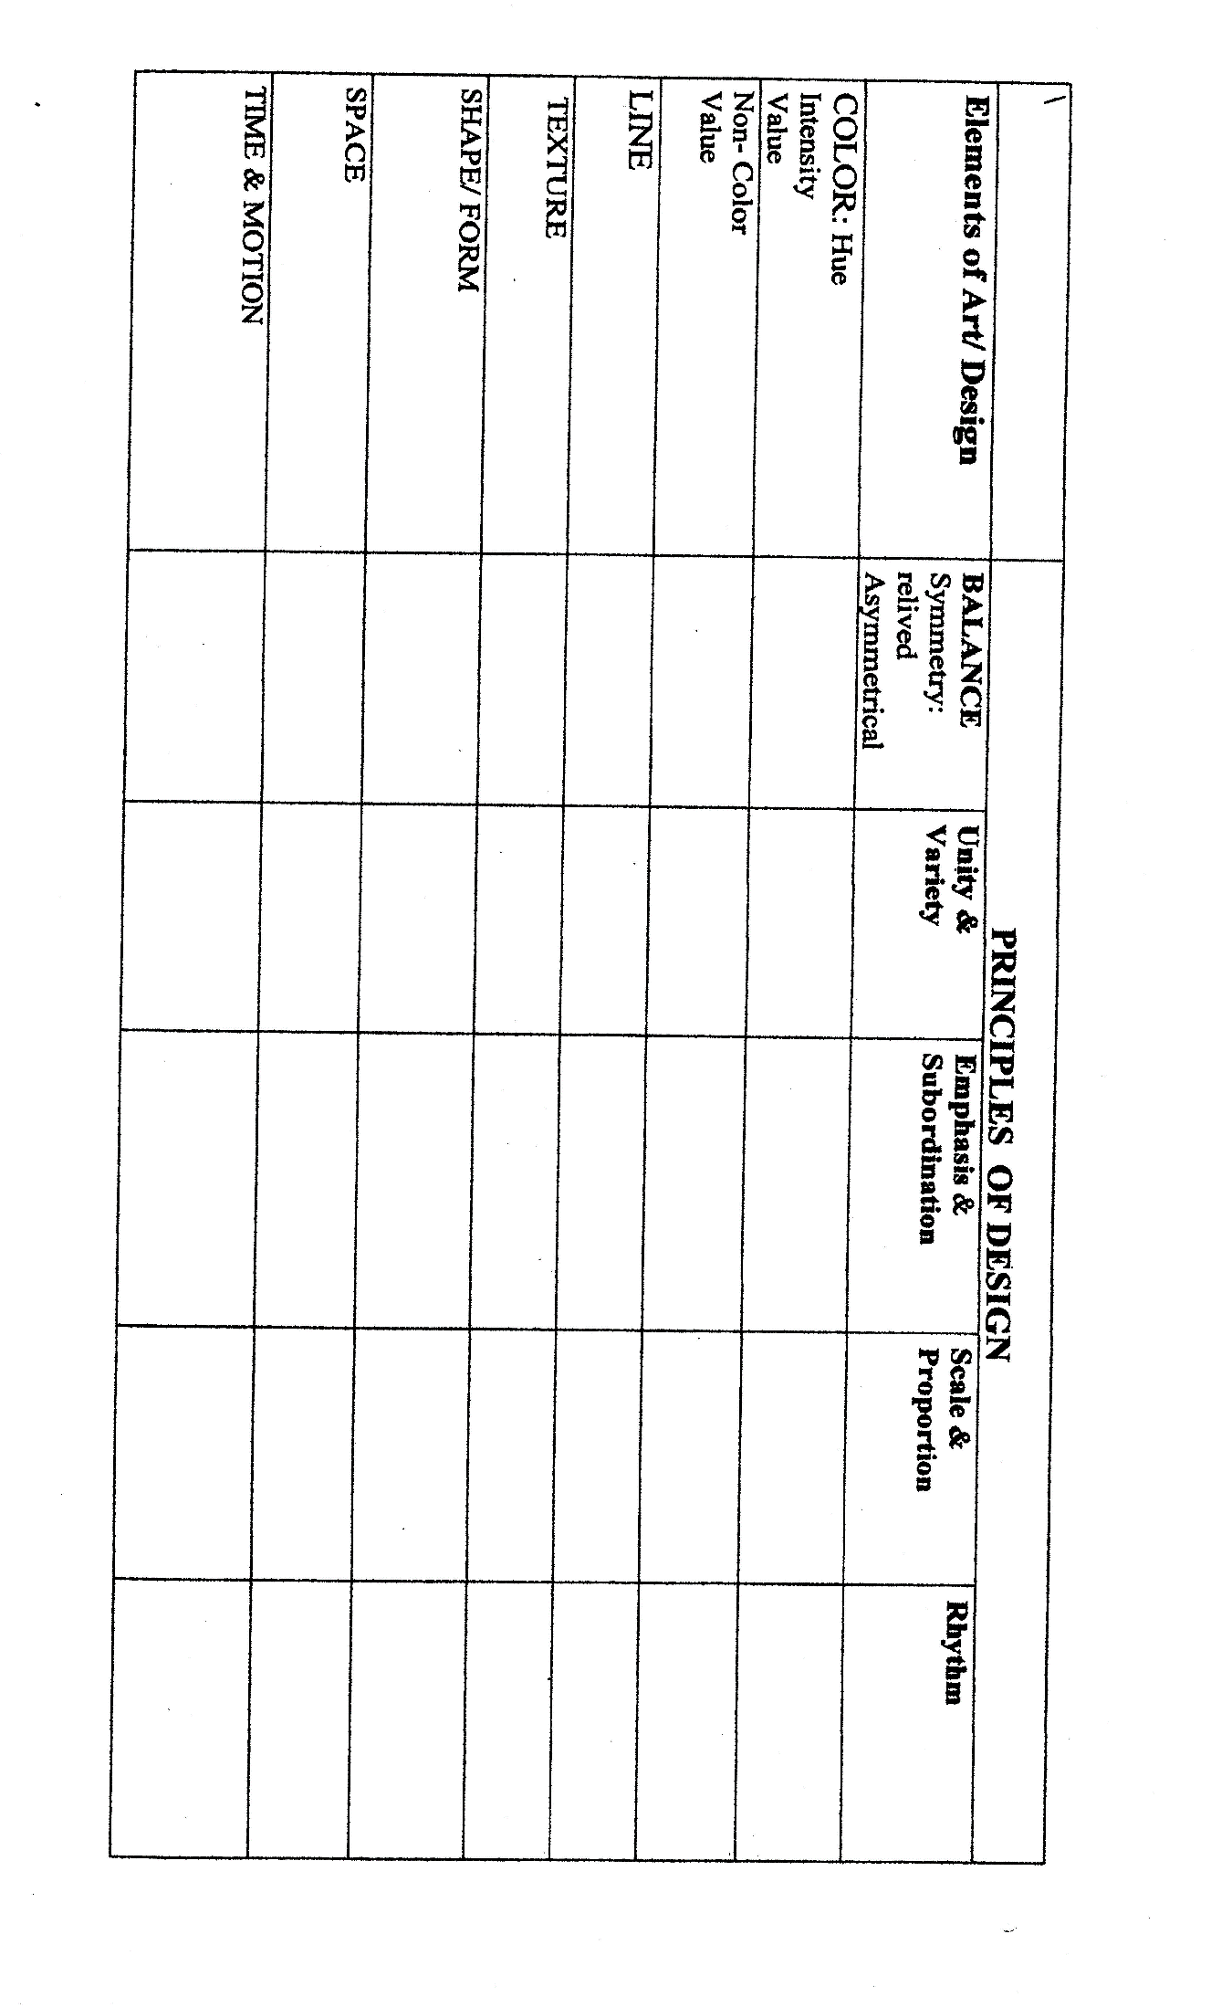
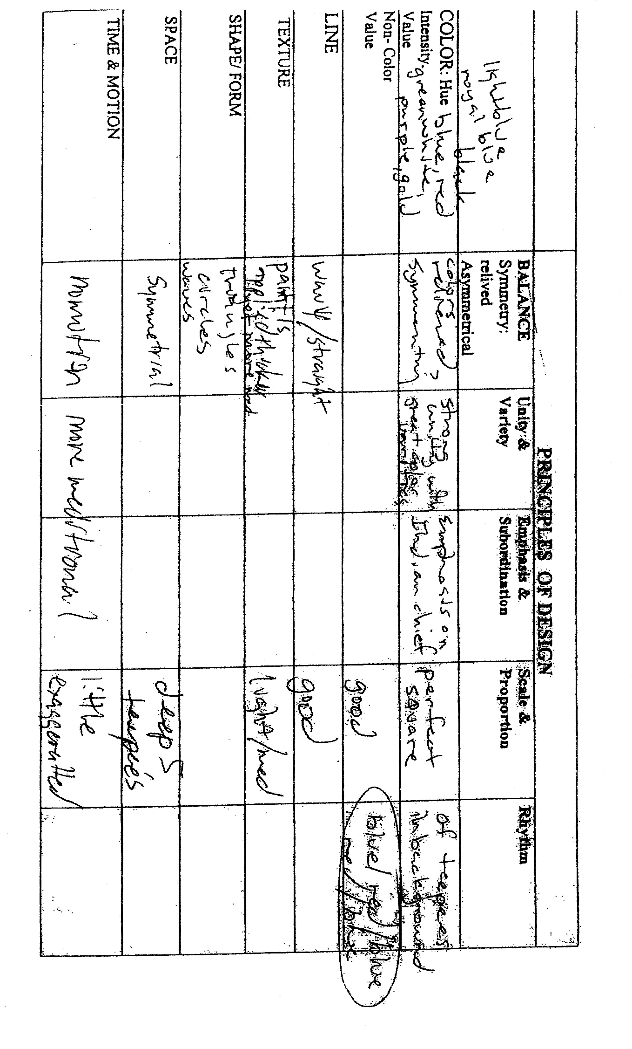

Checklist for Assignment #1-12
Museum Visit Report
Student. |  | Date Submitted:
final Grade |  | Date Completed
.  standard |  | Improvements needed | Meets  Standard
 |  | I. The artwork I liked:
The title, artist, date, material, and culture
What is the theme'
What type 01 visual art is it'' | ,t
What tools of the artist appeal to votO
What ideas and feelings did tlte artist communicate to you''
2. The artwork I didn't like:
(or a 2" one von liked
The title, artist, date. material. and culture.
What is the theme'
What type of visual art is al
What tools of the artist didn't (did) appeal to you?
What ideas and feelings didn't (did) the artist communicate to von )
 |  | 3. What surprised me at the museum:
Description If artwork, artist or idea:
Why it surprised me

